VMware Pro Cloud Service for Private Cloud Infrastructure - VCF Automation Design 9.x
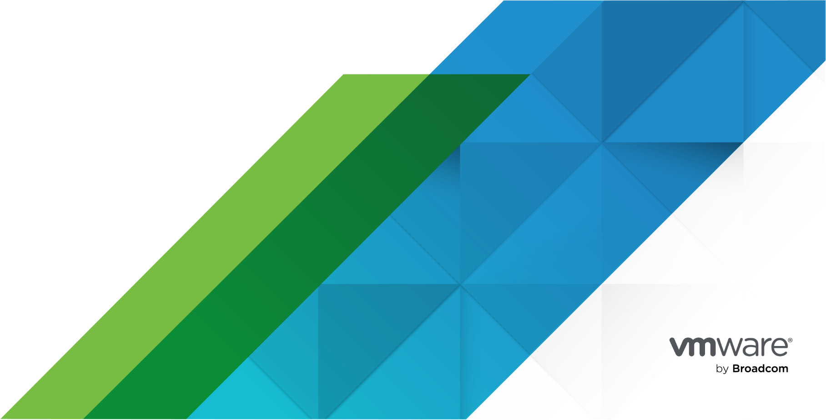
You can find the most up-to-date technical documentation on the VMware website at:
https://docs.vmware.com/
Broadcom®
3421 Hillview Ave.
Palo Alto, CA 94304
www.vmware.com
Copyright© 2026 Broadcom® All rights reserved. Copyright and trademark information.
Contents
1. Version History 4
2. Document Overview 5
Executive Summary 5
Document Focus 5
Conceptual Design Overview 5
Logical Design Overview 6
Conceptual Design 6
Conceptual Design Diagram 7
Solution Constraints 8
Solution Assumptions 8
Solution Risks and Risk Analysis 9
Solution Use Case Definition 10
Solution Verification Workbook(s) 12
3. VMware VCF Automation Low Level Design 13
Design Blueprints for VMware Cloud Foundation 13
VCF Automation Detailed Design 19
Simple VCF Automation Model 21
High Availability VCF Automation Model 24
Network Design Options for VCF Automation Instance Deployment 26
VCF Automation Models 27
VCF Automation Deployment Patterns 28
Tenancy Deployment Models in VCF 33
Multi Tenancy Consumption Patterns 42
VCF Automation Identity and Access Management Design 52
VCF Automation Load Balancing Design 60
VCF Operations Orchestrator Design 61
Chargeback and Billing 63
References 66

Version History
Date | Ver. | Author | Contributors | Description | Reviewers
Important Amend the text as needed and address the consultant and or architect notes. After completion, the notes can be removed. This text provides either sample guidance information, configuration recommendations for specific services, or customer-specific configurations.

Document Overview
This solution design document is created by VCF Professional Services to support the deployment of the Solution for Customer.
This document may be accompanied by other documents that focus on the implementation and operation aspects of the engagement, such as installation guides, solution specification and verification workbooks if implementation services are being performed.

Executive Summary
This executive summary aims to provide a short and comprehensive overview of the technical design, making it easier for decision-makers to understand the project's importance, benefits, and requirements without diving into the technical details.
architect Fill out this with the high-level business language in the below for the customer environment.
This design document outlines the plan for Customer <purpose of the engagement> by VCF Professional Services. The aim is to improve scalability, operational efficiency, and cost-effectiveness while ensuring a high level of security and compliance. The scope of this engagement includes <list main scope items>.
Developed using the VMware by Broadcom design methodology, the architecture aims to address <customers main problems and issues>. Some of the key features of the proposed design includes <technical capabilities that will be an output of the design>.
Upon approval, the next steps include extending the design to the implementation teams, initiating the integrations, and providing the teams with the necessary operational support as part of the handover.

Document Focus
This document, the Low-Level Design Document, is one of five main documents that which will collectively form the Low-Level design documents for the solution.
This includes the following content, which may be presented as one or more technical documents as required by the solution.

Conceptual Design Overview
The target audience is business executives, architects, and solution designers. A conceptual design serves as the foundational blueprint that captures high-level business needs, constraints, assumptions, and risks to guide the architecture of the VMware by Broadcom solution for Customer.
It lays out the primary business objectives/goals, and technical requirements within the given constraints, also calls out and validates assumptions, which are conditions believed to be true for the design. In addition to risks, which are potential challenges that may affect the project, are also identified, analyzed, and mitigated.
Furthermore, one of the crucial aspects of a conceptual design is the definition of use cases, which will ultimately be a core aspect in aligning the technical solution with the business objectives.
The conceptual design aim is to align the requirements with design qualities adhering to appropriate Availability, Manageability, Performance, Recoverability, Scalability, Cost and Security metrics for Customer . These are described more in the below table.
Table 2-1. Design Quality Descriptions
Design Quality | Description
Manageability | Indicates the effect of a design choice on the flexibility of an environment and the ease of operations in its management.
Security | Indicates the effect of a design choice to have a positive or negative impact on overall infrastructure security. Can also indicate whether a quality has an impact on the ability of a business to demonstrate or achieve compliance with certain regulatory policies.
Availability | Indicates the effect of a design choice on the ability of a technology and the related infrastructure to achieve highly available operation.
Performance | Indicates the effect of a design choice on the performance of the environment. This does not necessarily reflect the impact on other technologies within the infrastructure.
Recoverability | Indicates the effect of a design choice on the ability to recover from an unexpected incident, which affects the availability of an environment.
Scalability | Indicates the effect of a design choice on the ability to scale the environment as required to meet the demands of the workloads.
Cost | Indicates the effect of a design choice on the cost associated with the requirement.
Other | Fill in a custom category if the requirement doesn’t fit one above.

Logical Design Overview
The logical design serves as an intermediary layer between the conceptual design and the detailed physical design. It takes the overarching business objectives, constraints, assumptions, and risks established in the conceptual phase and translates them into a more technical architectural framework.
The logical design delves into several key areas of architecture. These include all aspects of the solution being covered within the scope of the engagement without going into the low-level details.
The logical design sets the framework for how the architecture will be realized in terms of management and consumption across areas related to compute, storage, networking, security, and disaster recovery.

Conceptual Design
This section details the conceptual design for the VMware by Broadcom Solution.

Conceptual Design Diagram
This solution is supported by relevant VMware by Broadcom products and technologies. The key attributes of this VMware by Broadcom solution are:
- Capability #1
- Capability #2
The following section(s) indicate the conceptual design(s) for the solution.

VMware Pro Cloud Services for Private Cloud Conceptual Design
This conceptual design has been custom built to depict the supported configurations for the Infrastructure as a Service (IaaS) platform in the environment. VMware Cloud Foundation and surrounding Aria technologies support multiple topologies which allow for the flexibility and availability of the configuration based on the needs of Customer's business.
The result is delivery of a prescriptive approach to developing and operating a VMware Cloud environment with improved agility and cost efficiency for the environment. It also allows for continuous improvement, and a self-service cloud experience for the consumer.
The following diagram illustrates the components of the VMware Pro Cloud Services for Private Cloud Solution and their relationships.
Figure 2-1. Conceptual Design - VMware Pro Cloud Services for Private Cloud
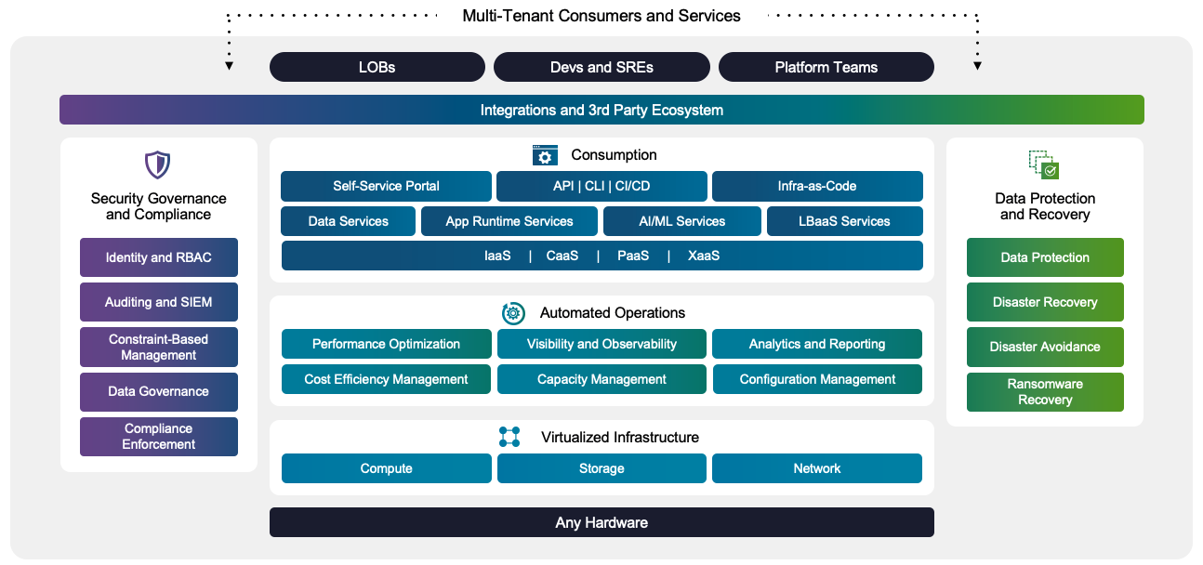
In a VMware Pro Cloud Services for Private Cloud engagement, there are three maturity layers, and some common functions, as shown in the diagram below. The layers are as follows:
- Virtualized Infrastructure - This layer includes the instantiation of the VMware Cloud Foundation environment, including the deployment of the ESX Hosts, vCenter Server, NSX networking, VCF Operations, VCF Operations Fleet Management and SDDC Manager.
- Automated Operations - This layer adds additional deployment of VCF Operations for Logs, and Aria Suite Operations for Networks. It also includes workshops to be able to include dashboards, cost efficiency and capacity management.
- Consumption - This layer adds VCF Automation and a basic configuration of a catalog to the environment. Further integrations and third party ecosystem configurations can be added as an addon element beyond the default configuration
As a part of the environment, there are also the following functions:
- Common Functions - These functions are required for the entire platform and are cornerstones to being successful with a Private Cloud. Functions such as Lifecycle Management and security are built right into the platform to ensure that it is able to be operated in an efficient way.
- Operational Assistance - This function is required to implement the required organizational transformation to be successful with the new platform.
The remainder of this section covers the Requirements, Service Level Objectives, Constraints, Assumptions, Risks and Use Cases specific as appropriate for Customer. This may include one or more of the areas above based on the solution being instantiated.

Solution Constraints
This section describes the constraints which are applicable to the engagement.
Table 2-2. Constraints
ID | Constraint
CO1
CO2
CO3
CO4
CO5
CO6

Solution Assumptions
This section describes the assumptions which are applicable to the engagement.
Table 2-3. Assumptions
ID | Assumption Area | Description
AS1
 | Validation
AS2
 | Validation
AS3
 | Validation
AS4
 | Validation
AS5
 | Validation
AS6
 | Validation

Solution Risks and Risk Analysis
This section describes the risks and risk mitigation measures which are applicable to the engagement. This section focuses on the major risks that touch on the entire solution and their analysis, versus an individual design decision risk.
Table 2-4. Risks
ID | Risk Area | Risk Details | Risk Level
RI1 |  |  | High | Medium | Low
 | Analysis
 | Mitigation
RI2
 | Analysis
 | Mitigation
RI3
 | Analysis
 | Mitigation
RI4
 | Analysis
 | Mitigation
RI5
 | Analysis
 | Mitigation
RI6
 | Analysis
 | Mitigation

Solution Use Case Definition
This section provides use cases identified during interactive requirements gathering sessions between Customer and VCF Professional Services.
Use cases will serve as a common language between Customer stakeholders and technical teams. This alignment ensures the architecture is purpose-built to solve actual business problems. Use cases are a very effective method in relaying the expected outcomes in an understandable way.
Use cases are invaluable for quality assurance as well, serving as a basis for deriving test cases that validate the system against real-world scenarios. Additionally, they assist in scalability and performance planning, informing decisions on how robust the system needs to be to handle anticipated workloads. In addition, the well-defined use cases for Customer will also aid in solidifying the end-user acceptance and confidence in the system.
Remember Fill out the User Communities/Roles and Use Cases as appropriate for the customer. The first entry is an example that should be removed.

Use Case 001 - <Use Case Title>
UC001
Objective
Actors
Action Flow
Frequency
Dependencies

Use Case 002 - <Use Case Title>
UC002
Objective
Actors
Action Flow
Frequency
Dependencies

Use Case 003 - <Use Case Title>
UC003
Objective
Actors
Action Flow
Frequency
Dependencies

Use Case 004 - <Use Case Title>
UC004
Objective
Actors
Action Flow
Frequency
Dependencies

Use Case 005 - <Use Case Title>
UC005
Objective
Actors
Action Flow
Frequency
Dependencies

Use Case 006 - <Use Case Title>
UC006
Objective
Actors
Action Flow
Frequency
Dependencies

Solution Verification Workbook(s)
The solution verification workbook(s) act as structured guides for the comprehensive testing and validation of the VMware by Broadcom solution prescribed within the architecture. These workbooks are pivotal for quality assurance, defining test objectives aligned with the solution's functional and non-functional requirements, outlining specific test scenarios and procedures.
The solution verification workbooks provide detailed step-by-step instructions for executing each test, including the setup requirements, and expected outcomes, and feature explicit pass/fail criteria to quantify success or failure. The workbooks also have designated sections for recording actual test results, documenting anomalies or issues encountered.
The solution verification workbooks are an anchor for ensuring the implemented VMware solution is ready for production, meeting both technical specifications and organizational goals.

VMware VCF Automation Low Level Design

Design Blueprints for VMware Cloud Foundation
To assist with choosing an architecture for your specific business and technology requirements, the Design Blueprints section provides a set of pre-defined architecture topologies, based on specific design profiles. To deliver a ready-to-consume solution, providing the full set of capabilities (end-to-end design) offered by the VMware Cloud Foundation platform, each Design Blueprint provides a prescriptive selection of the deployment models available for each VMware Cloud Foundation component.

Understanding Design Blueprints
A VMware Cloud FoundationDesign Blueprint:
- Is a prescriptive end-to-end design for a VCF fleet in a commonly requested architecture topology, created to help accelerate time to value when building a new VMware Cloud Foundation platform.
- Has a prescriptive selection of deployment models chosen from the design library to conform to the design profile of the Design Blueprint.
- Can be deployed as is, with no alterations, or can be used as template where any of the deployment models can be substituted for alternatives from the same category within the design library. See Design Library for .
- Reflects the initial deployment of a VCF fleet and supports expansion in a variety of ways to support the needs of your organization.
- Provides a set of planning, implementation and design elements (requirements and recommendations) based on the chosen deployment models.

Choosing and Using a Design Blueprint
Important Before assessing any of the provided Design Blueprints, you should familiarize yourself with the options available within the VCF architecture, by reading the Architectural Options in section of this document. This will help you understand the ways in which you can substitute selections within the Design Blueprint for other deployment models that better suit your organizations needs.
This design guide covers the following pre-defined Design Blueprints:
- VCF Fleet in a Single Site with Minimal Footprint
- VCF Fleet in a Single Site
- VCF Fleet with Multiple Sites in a Single Region
- VCF Fleet with Multiple Sites across Multiple Regions
- VCF Fleet with Multiple Sites in a Single Region plus Additional Region(s)
Each Design Blueprint has a Design Profile section to help you quickly establish if the Design Blueprint is a good fit for your organizational needs, and is structured using the following categories:
- Consumption
- Physical Site Configuration
- Availability
- Isolation
- Recoverability
- Expansion
Review each of the Design Blueprints provided until you find the one that most closely matches your requirements. If it is a perfect fit, then use it as is to deploy your VCF fleet. If it is not a perfect fit, then using the knowledge you gained in the Architectural Options in section of this document, review the Design Selections sections of the Design Blueprint and substitute any of the selected models for alternatives from the same category in the design library to create your own custom Design Blueprint. Each substituted model will have a list of its specific design elements in its section within the design library.
Once your pre-defined or custom Design Blueprint it deployed, your VCF fleet may evolve according to your emerging needs of your organization. While you may choose to evolve your VCF fleet to align with different blueprints over time, there is no requirement to expand in any given manner, or to remap your organization to a different blueprint should that evolution take your configuration in a different direction than the initial deployment.

Understanding Physical Site Configurations
The following terminology definitions help you better understand the provided Design Blueprint in the context of the physical site configuration.
Term | Definition in a Design Blueprints Context
Region | - A region is comprised of one of more physical sites in a single metropolitan area i.e. within synchronous replication latencies.  - Recovery of management/business workloads between regions is a disaster recovery process.
Single Site | - A site represents a logical and a physical boundary that is managed as a single, contained entity. It may offer levels of isolation at the physical layer (power, HVAC, connectivity, etc.) but represents a single fault domain for at least one level of infrastructure.  - VCF fleet (management and business workloads) are deployed in a single site.  - Protecting any given component or workload to another site is not within the scope of a Design Blueprint, as recovery generally depends upon a second (recovery) site.  - A single site can support multiple clusters, workload domains and VCF Instances based on the scale and workload isolation required.
Multiple Independent Sites | - VCF fleet (management and business workloads) are distributed across multiple independent sites, but one site will operate the VCF fleet management components, creating a level of dependency on that one site.  - Sufficient network connectivity exists between sites to facilitate centralized management. This generally means layer-3 connectivity with separate, non-overlapping IP address spaces at each site  - Either the latency or bandwidth are not suited to protecting management components and business workloads across sites, or there is no desire to do.  - Additional sites can be deployed as follows based on requirements:  - Clusters in existing VCF domains.  - Additional VCF domains.  - Additional VCF Instances with appropriate VCF fleet management components.  - Each site can support multiple clusters, workload domains and VCF Instances based on the scale required
Multiple Sites in a Single Region | - VCF fleet is distributed across multiple sites that are connected to provide centralized management and site resilience for management and/or business workloads.  - Latency and bandwidth are suitable for protecting management and/or business workloads across sites using stretched cluster technology or any other protection level (based on their individual requirements) by leveraging the appropriate vSphere Cluster Model.  - With the use of stretched clusters, the VCF fleet management components, as well as other management and customer workloads can operate across a pair of sites to provide enhanced availability at the infrastructure layer, in addition to application-layer availability capabilities.  - Additional sites can be deployed as follows based on requirements:  - Clusters in existing VCF domains.  - Additional VCF domains.  - Additional VCF Instances or to stretch clusters between sites.  - Each site can support multiple clusters, workload domains and VCF Instances based on the scale required  - Provides a suitable platform for a layered disaster recovery solution if required.
Multiple Sites across Multiple Regions | - VCF fleet is distributed across multiple sites that are connected for the purpose of providing site resilience for management and/or business workloads, as well as for centralized management.  - Latency and bandwidth are not suitable for protecting management and/or business workloads across sites using stretched cluster technology, but may be used to provide all other protection levels (based on their individual requirements) by leveraging the appropriate vSphere Cluster Model.  - One site will operate the VCF fleet management components, and additional sites can be deployed as follows based on requirements:  - Clusters in existing VCF domains.  - Additional VCF domains.  - Additional VCF Instances.  - Each site can support multiple clusters, workload domains and VCF Instances based on the scale required  - Provides a suitable platform for a layered disaster recovery solution if required.

VCF Fleet Architecture and Blueprints
Each of the Design Blueprint in this section has a scope of a single VCF fleet. VCF fleets are completely independent from a management and operational perspective, and have no shared components.
A VCF private cloud may contain multiple VCF fleets, related through layers outside of the VCF boundary - for example applications may have components in multiple VCF fleets, multiple VCF fleets may also share some underlying physical infrastructure such as datacenters (sites), racks, and network equipment, or be associated with a common external management platform.
To determine whether a deployment should be contained within an entire VCF fleet or spread across different VCF fleets a number of factors need to be reviewed:
Physical Location
- Since the VCF Operations, Fleet Management & VCF Automation components will reside in the initial cluster, all the resources within the VCF Fleet should be within suitable latency, and support sufficient network bandwidth for traffic to and from the initial cluster management components and the ESX hosts and workloads in other locations.
Environment Role or Compliance Separation
- To support validating end-to-end upgrades or physical isolation, if full separation is required between environments providing different roles (for example Development, Testing, Pre-Production, Production or environments that adhere to a specific compliance regime) , it may be necessary to have separate VCF Fleets for these different environments.
Scale
- If any aspect of the environment may exceed the scale limits for a VCF Fleet (see ConfigMax), it should be proactively divided into multiple VCF Fleets based on logical boundaries to avoid hitting a scale limit during a growth period.
Business Organization
- In some cases there may be a desire to fully isolate groups at all levels of infrastructure and applications. Although VCF provide a multi-tenant experience, in cases where a potential divestiture is planned, or for other business requirements, separate VCF Fleets may be desired for different business groups.
Availability Requirements
- If there are different environments that have different availability requirements for the VCF Fleet management components, you can either build to the highest requirement, or separate the workloads into different VCF Fleets that match the availability requirements of the workloads they will manage.
Once the VCF Fleet layout is determined for the organization, the most appropriate Blueprint for each environment can be selected for its VCF Fleet, and scaled out as needed.

Disaster Recovery
Disaster recovery is the process of recovering management and/or business workloads between sites and has the following attributes:
- The fail-over is “crash consistent” - the running state of workloads is not maintained by the infrastructure.
- There is a Recovery Point Objective (RPO), which is a delay in time between when data is written to storage in one location and when it is replicated to the other location.
- There is a Recovery Time Objective (RTO), which is the amount of time it takes for the workloads to be operational in the second location once the manually-initiated fail-over process is started.
- Typically this type of process is carried out between sites with latency too great to support synchronous replication of data.
- It may also be used between sites that have a much shorter latency, but where there is a desire to guard against the scenario where logical corruption of data is instantly replicated to other sites via synchronous replication.
Recovery with Design Blueprints
- All Design Blueprints support the recovery of management components through a backup and restore process, where backups can be scheduled automatically.
- Some management components support additional distributed availability models that can serve as a recovery solution under certain failure scenarios (for example VCF Operations can run in a continuous availability model across multiple regions). Other management components that do not support native backups, can be used with standard vSphere supported backup and recovery products.
- To successfully recover workloads in the event of a failure, all described solutions require the development of a recovery plan, addressing the compute resources (including storage) and network connectivity required at each site and the orchestration of moving workloads between the two sites. This plan should be rigorously validated and tested regularly to ensure its accuracy and completeness. The development and validation of the recovery plan is not within the scope of this guide or the listed Design Blueprints.
In addition to the backup and recovery model, which can be leveraged for customer workloads (using a separately available backup and restore solution), there are availability constructs, covered by Design Blueprints, that can address some of your recoverability and Business Continuity / Disaster Recovery (BC/DR) requirements:
- Stretched Clusters: VCF Fleet with Multiple Sites in a Single Region and VCF Fleet with Multiple Sites in a Single Region plus Additional Region(s)Design Blueprints include a stretched cluster model between 2 sites within the same region. This is technically an availability model rather than a recovery model (since any disk writes are instantly replicated to the remote site), however, it can still provide recovery options for certain types of failure scenarios.
- Remote site recovery: VCF Fleet with Multiple Sites across Multiple Regions and Blueprint 5 include designs with multiple locations in different regions. While the scope of the Design Blueprints does not include implementing a data replication and workload recovery solution, the design provides a suitable basis for replicating workload data and orchestrating fail-over of workloads to the recovery site using VMware Live Recovery or a third party product.

Expansion after Design Blueprint Deployment
The included Design Blueprints are starting points for the initial deployment and cover either a management domain only, or a management domain and the first workload domain. All VCF deployments may be expanded in the following ways and are subject to the limits defined in VMware Configuration Maximums.
Type of Expansion | Methods of Expansion
Resource Expansion | - Add additional hosts to an existing vSphere cluster.  - Provides additional compute capacity (and storage if using vSAN) with automated workload balancing and failover within the scope of the entire cluster. All hosts in a cluster must have the same configuration and access to resources (networking, storage)  - Add additional vSphere clusters to an existing VCF domain.  - Provides additional compute capacity (and storage if using vSAN) in an isolated scope from workloads in other clusters. Can have different configuration, networking and/or storage from other clusters. Automated failover and workload balancing does not span across clusters.  - Add additional workload domains to an existing VCF Instance.  - Provides separate management & control plane (vCenter) from other workload domains, allowing for different configurations or to support separate locations or access.  - Add additional VCF Instances to an existing VCF fleet  - Provides separate management & networking from other instances, allowing for different configurations or to support separate locations, while maintaining a common consumption instance (VCF Operations, VCF Automation and Fleet Management.
Availability Expansion | - Add Interconnected Site (in the same region) *  - Add Interconnected Site (in another region) *
Note * Once a new site has been added, additional steps are required to leverage additional availability by deploying additional or modifying the configuration of existing vSphere clusters to use that site.

VCF Automation Detailed Design
This section describes the options, requirements, and recommendations for each VCF Automation deployment model.
VCF Automation can be deployed during initial deployment of your VMware Cloud Foundation platform by using VCF Installer, or at a later stage by using VCF Operations to use a custom network configuration.
Table 3-5. VCF Automation Deployment Paths
Deployment Path | Implications
Deployment by using VCF Installer, see Start a New VCF Fleet or a New VCF Instance Deployment by Using the VCF Installer Deployment Wizard | - Part of an initial net new VCF deployment along with other core management domain components (for example, vCenter, NSX, VCF Operations, SDDC Manager, etc.)  - Uses VCF Management DVPG network by default
Deployment by using VCF Operations fleet management for custom networking configuration. | - Post VCF core management components deployment  - Allows for custom network configurations
VCF Automation enables building a modern private cloud and plays a crucial role in both single-tenancy and multi-tenancy scenarios by providing a unified platform for designing a modern private cloud platform with VMware Cloud Foundation.
Modern private cloud platform from the service provider perspective:
- Single tenancy: service providers offer dedicated private cloud environments to customers who require strong isolation, compliance, or specific performance guarantees.
- Multi-tenancy: service providers use multi-tenancy to deliver cost-effective, shared cloud services to a broader customer base.
Modern private cloud platform from the Enterprise perspective:
- Single tenancy: enterprises use single tenancy to isolate sensitive workloads, critical applications, or different business units with specific requirements.
- Multi-tenancy: enterprises use multi-tenancy for internal IT infrastructure to improve efficiency, reduce costs, and simplify management of less critical applications.
This design section is intended to guide both enterprise and service providers in designing and deploying a modern private cloud with VCF Automation tailored to their organizational needs.
Throughout this VCF Automation design, the terms Organization, Tenant, Organization Admin, and Tenant Admin may be used interchangeably depending on the reader’s operational context — whether an enterprise IT team or a service provider.
Table 3-6. VCF Automation Terminology
Term | Description | Context Example
Organization | - It can be a department or a line of business for an enterprise Or  - It can be Tenant for a service providers | - Finance department in a large enterprise  - It can be Tenant for a service providers
Provider Admin | User role responsible for managing the overall infrastructure, services, and tenancy model across multiple organizations or tenants. | Administrator managing multi-tenant VCF Automation environment.  This role can either be an Enterprise IT Admin in an enterprise environment or a Provider Admin in a service provider context.
Organization Admin / Tenant Admin | User role responsible for managing resources, workloads, and permissions within their own organization/tenant. | Both refer to roles managing resources within their respective organizations/tenants.
VCF Automation Portals
Name | Location | Description
Provider Portal | https://<VCF Automation Appliance FQDN>/automation; Organization: system | Infrastructure and Resource defintions, Organization creation and networking + resource allocation
Organization Portal | https://<VCF Automation Appliance FQDN>/automation; Organization: <Customer Organization> | Configuration of Organization's allocated resources, projects, blueprints and self-service workload deployments.
In addition, the Provider will also rely direct access to vCenter and NSX Manager for some infrastructure configurations. For example, NSX Edge Cluster creation and Supervisor Cluster activation.

Simple VCF Automation Model
The Simple VCF Automation Model consists of a single node deployed in a vSphere cluster. Availability is provided by the native vSphere HA functionality within the vSphere cluster.
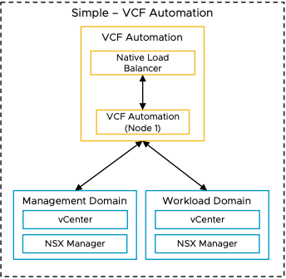

Simple VCF Automation Model Attributes
A Simple VCF Automation Model has the following attributes.
Attribute | Detail
Availability | Relies on vSphere HA to restart the nodes in the event of an ESX host failure.
Scalability | Supports scale-up and scale-out to high the availability model.  Note Scale-up to a larger node size and scale-out to three nodes at the same time.
Recoverability | Restore through a backup.

Simple VCF Automation Model Options
A Simple VCF Automation Model can leverage options from the design areas listed below, depending on objectives.
Design Area | Options
Network Placement | Deploy on the default VCF Management DVPG network
 | Deploy on a separate dedicated DVPG network
 | Deploy on a separate NSX overlay network

Simple VCF Automation Model Design Requirements
Table 3-7. Simple VCF Automation Model Design Requirements
Design Requirement ID | Design Requirement | Justification | Implication
VCF-AUTO-REQD-SIM-001 | Deploy as a single node in the default management vSphere cluster. | - Supports the simple deployment objective.  - supports scale out and up to a high availability model. | - The simple deployment model defaults to the small appliance size.  - Administrators will need to be aware of the scale and performance implications of the small size node to their design.  - If deployed through VCF Installer, the installer will deploy the small appliance by default.  - If deployed via VCF Operations fleet management, you will have to select the small appliance size to deploy the simple model.
VCF-AUTO-REQD-SIM-002 | Deploy VCF Automation in separate DVPG or NSX Overlay through VCF Operations fleet management Or SDDC Manager API | Supports different network other than default management network for security requirements. | If deployed via VCF Operations fleet management, all the VCF Operations components (to include fleet manager) will need to be fully up and functional prior to starting the deployment.
VCF-AUTO-REQD-SIM-003 | Protect the nodes by using vSphere HA. | Ensures availability of without requiring manual intervention during an ESX host failure event. | None.

Simple VCF Automation Model Design Recommendations
Table 3-8. Simple VCF Automation Model Design Recommendations
Design Recommendation ID | Design Recommendation | Justification | Implication

High Availability VCF Automation Model
The High Availability VCF Automation Model consists of a three-node deployment. This model provides resiliency at both the application level through the clustered deployment as well as the vSphere cluster level through vSphere HA and vSphere DRS functionality.
The high availability discussion in this section focuses on the VCF Automation appliance level. For discussions on high availability design for components supporting VCF Automation, see the following:
- vSphere Clusters - See vSphere Cluster Detailed Design for more details.
- vSphere Supervisor deployments - See vSphere Supervisor Detailed Design for more details.
- NSX Edges - See NSX Edge Cluster Detailed Design for more details.
For a discussion on high availability as it pertains to tenant design, please review the "Enable Modern Private Cloud with VCF Automation" Guide.
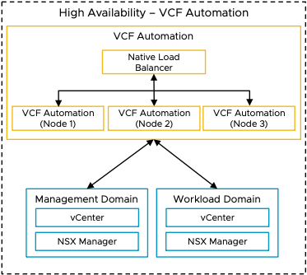

High Availability VCF Automation Model Attributes
A High Availability VCF Automation Model has the following attributes.
Attribute | Detail
Availability | - Application level availability provided by the three node cluster  - Appliance level level availability provided by vSphere HA
Scalability | Supports scale-up and scale-down of node sizes.
Recoverability | Restore through a backup.

High Availability VCF Automation Model Options
A High Availability VCF Automation Model can leverage options from the design areas listed below, depending on objectives.
Design Area | Option
Network Placement | - Deploy on the default VCF Management DVPG network  - Deploy on a separate dedicated DVPG network  - Deploy on a separate NSX overlay network
External Load Balancing | - External load balancer configuration is a post deployment configuration.  - The native Kubernetes load balancer is configured automatically during deployment of VCF Automation and cannot be removed.  - The external load balancer must be configured to send traffic to the native Kubernetes load balancer configured at deployment.  - The external load balancer requires VIP addressing, FQDN, as well as a certificate in addition to those assigned at deployment.

High Availability VCF Automation Model Design Requirements
Table 3-9. High Availability VCF Automation Model Design Requirements
Design Requirement ID | Design Requirement | Justification | Implication
VCF-AUTO-REQD-HA-001 | Deploy as a three node cluster in the default management vSphere cluster. | Supports high availability objectives. | - Analysis will be required to determine which node size is appropriate for your deployment.  - Node can be resized after deployment as necessary.
VCF-AUTO-REQD-HA-002 | Deploy VCF Automation in separate DVPG or NSX Overlay as a three node cluster through VCF VCF Operations fleet management. | Supports different network other than default management network for security requirements. | If deployed via VCF Operations fleet management, all the VCF Operations components (to include fleet manager) will need to be fully up and functional prior to starting the deployment.
VCF-AUTO-REQD-HA-003 | If VCF Automation is deployed as high availability deployment will default to the medium node size. Review the configuration maximums for the medium node size to determine if it will be sufficient for your use cases | Ensures that the VCF Automation node sizing is appropriate for your use cases. | If your use cases require the large size nodes you will need to perform a scale up action through VCF Operations fleet management post deployment.
VCF-AUTO-REQD-HA-004 | Protect all nodes by using vSphere HA. | Supports the high availability objective without requiring manual intervention during an ESX host failure. | None

Network Design Options for VCF Automation Instance Deployment
Each customer has different use cases and network requirements to place VCF Automation on VMware Cloud Foundation management domain. VMware Cloud Foundation provides flexibility of network segment options for our customers to design their private cloud. Below are the design options to choose which best fits your requirements.
Network Design Options | Justification | Implication
Deploy on the default VCF Management DVPG network | - Default deployment through VCF Installer  - Quick and easy deployment as it uses the default management network  - Does not require separate network or VLAN. | - Management network will need to have enough available IP addresses to support the VCF Automation deployment.  - Moving to a separate network from the default management network may require a redeployment of VCF Automation.
Deploy on a dedicated DVPG network | - Would like to separate user facing networks from management networks to meet regulatory and security requirements.  - Additional VLAN required. | - If this option is chosen, VCF Automation deployment cannot happen through VCF Installer.  - VCF Automation installation must be deployed through VCF Operations fleet management.  - VLAN will need to be created prior to VCF Automation deployment
Deploy on a separate NSX overlay network | - Would like to separate user facing networks from management networks to meet regulatory and security requirements.  - Future DR Ready.  - Additional Segment needed in NSX VPC | - If this option is chosen, VCF Automation deployment cannot happen through VCF Installer.  - VCF Automation installation must be deployed through VCF Operations fleet management  - Overlay network will need to be created prior to VCF Automation deployment  - VCF automation can be deployed via API call.

VCF Automation Models
VMware Cloud Foundation uses VCF Automation as the central provisioning platform for your VCF fleet. VCF Automation enables consumption of Kubernetes and cloud infrastructure resources as a service, while maintaining control, security, and compliance.
VCF Automation runs on containers within a Kubernetes cluster, deployed on dedicated virtual appliances. VCF Automation infrastructure is visible in the vCenter inventory as individual nodes. During installation, the fleet management services automatically provision the Kubernetes cluster to orchestrate the deployment of the VCF Automation component containers and services. VCF Operations fleet management transparently manages the Kubernetes cluster.
Table 3-10. VCF Automation Models in VMware Cloud Foundation
Model | Attributes | Benefits | Implications
Simple VCF Automation Model | - Single node  - Applies to Small appliance size  - Can be scaled out to the high availability model by resizing the node to Medium or Large, which also forces the scale out to 3 nodes | - Recommended deployment scenarios:  - Proof of Concept (POC) or evaluation.  - Small-scale, non-critical workloads.  - Development and testing environments. | No application-level high availability.
High Availability VCF Automation Model | - Three node cluster.  - Applies to Medium or Large node sizes.  - Supports use of an external load balancer. | - Recommended deployment scenarios:  - Production environments.  - Mission-critical applications.  - Enterprise deployments.  - Scalable infrastructure, ideal for organizations that anticipate future growth and need the ability to scale their infrastructure resources.  - Can be scaled up or down in size as necessary (for example, from medium to large nodes or the reverse). | Provides application-level availability.
Figure 3-2. VCF Automation Models in VMware Cloud Foundation
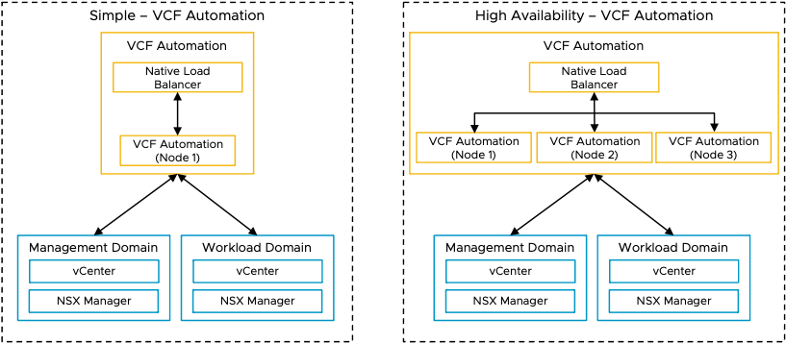

VCF Automation Deployment Patterns
This section explains different deployment patterns of VCF Automation within VMware Cloud Foundation single and multi-domain architectures.

Deployment Pattern 1: VCF Automation in a VCF Instance with Single Domain and Multiple Clusters
VCF Automation is deployed in a management domain and organization workloads are placed in a different vSphere cluster of the same management domain.
Figure 3-3. VCF Automation in a VCF Instance with single domain and multiple clusters
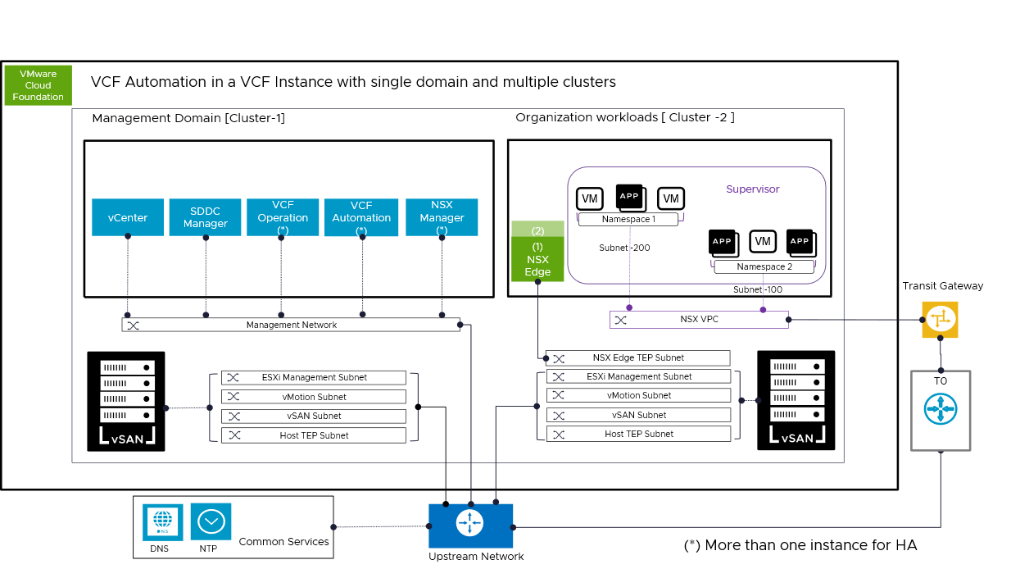
This deployment pattern separates the management and compute resources into two vSphere clusters in a single domain. The management domain hosts the core management components of VCF. In this deployment pattern, different subnets are used for various traffic types, ensuring security and performance. A Transit Gateway is used to connect upstream network and it serves as a high-level network routing hub, linking multiple subnets, and networks across the architecture.
The vSphere cluster that hosts the organization workloads has NSX VPC configured and vSphere Supervisor enabled to consume a modern private cloud with VCF Automation.
This deployment pattern enables High Availability through the deployment of multiple instances of components to provide redundancy and ensure reliability.
1. This architecture consolidates the management and compute resources into two primary clusters in a single domain: Cluster-1 (management) and Cluster-2 (workload).
2. [Cluster-1]: This hosts the core management components of VCF such as vCenter, NSX, SDDC Manager, VCF Operation and VCF Automation.
3. [Cluster-2] : It has multiple VMs and App instances, indicating that it is primarily focused on hosting applications and workloads for Tenants.
5. It shows clear separation between the Management and the Workload cluster.
6. As per VCF deployment guidelines, different subnets are used for various traffic types, ensuring security and performance.
7. NSX VPC and Supervisor Cluster is enabled in Cluster 2 to consume a modern private cloud with VCF Automation.
8. Transit Gateway (TGW) is used to connect upstream network and it serves as a high-level network routing hub, linking multiple subnets, and networks across the architecture.
9. Ensures that common services such as DNS and NTP is configured appropriately for VCF Automation to work properly.
10. This setup allows High Availability (HA), with an asterisk (*) indicating that multiple instances of components can be deployed to provide redundancy and ensure reliability.
Benefits | Drawbacks
- Fast deployment  - Simplified integrated management  - Dedicated VCF Instance for a Tenant or a Line of Business  - Near Edge Deployments Smaller Environments and no plan of growth  - Smaller hardware footprint  - VCF Automation HA is an option | - Limited scalability than VCF standard architecture  - Management Overhead to manage each VCF Instance for dedicated Tenant  - VCF Automation HA deployment will consume more infrastructure resources

Deployment Pattern 2: VCF Automation in a VCF Instance with multiple domains
VCF Automation is deployed in a management domain and organization workloads are placed in a workload domain.
Figure 3-4. VCF Automation in a VCF instance with multiple domains for workloads
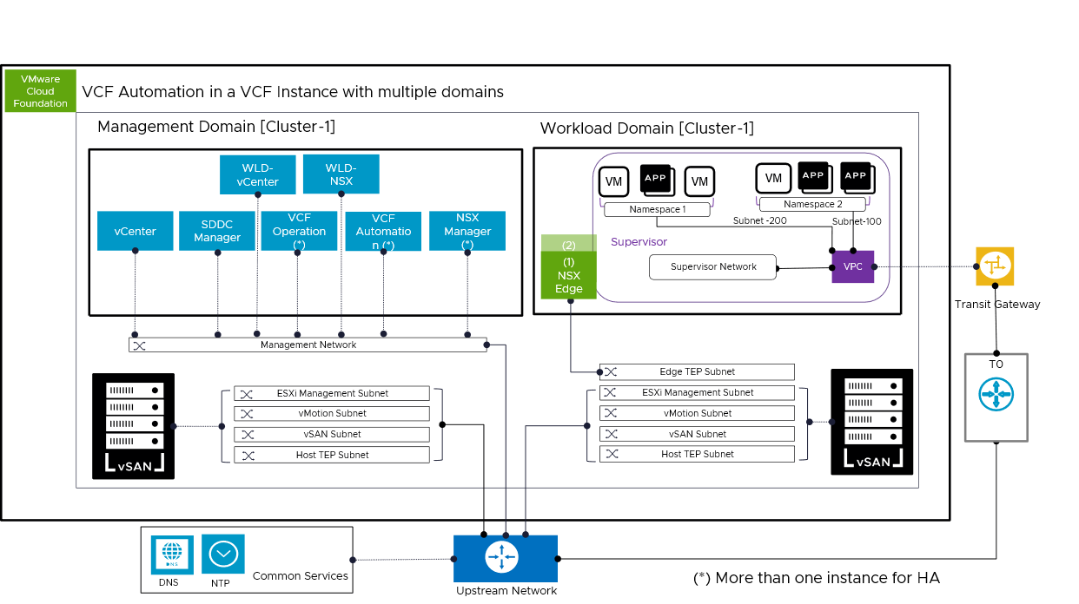
The Management domain hosts the core management components of VCF. The workload domain hosts the tenant virtual machines. different subnets are used for various traffic types, ensuring security and performance. In this deployment pattern, different subnets are used for various traffic types, ensuring security and performance. A Transit Gateway is used to connect upstream network and it serves as a high-level network routing hub, linking multiple subnets, and networks across the architecture.
The vSphere cluster that hosts the organization workloads has NSX VPC configured and vSphere Supervisor emabled to consume a modern private cloud with VCF Automation.
This deployment pattern enables High Availability through the deployment of multiple instances of components to provide redundancy and ensure reliability.
1. A Management Domain [Cluster-1]: This domain hosts the core management components of VCF such as vCenter, NSX, SDDC Manager, VCF Operation and VCF Automation.
2. A Workload Domain [Cluster-1]: This workload domain is where the actual Tenant virtual machines (VMs) and applications run.
3. Clear separation between the Management Domain and the Workload Domain.
4. As per VCF deployment guidelines, different subnets are used for various traffic types, ensuring security and performance.
5. NSX VPC and Supervisor Cluster is enabled in workload domain to consume a modern private cloud with VCF Automation.
6. Transit Gateway (TGW) is used to connect upstream network and it serves as a high-level network routing hub, linking multiple subnets, and networks across the architecture.
7. Ensures that common services such as DNS and NTP is configured appropriately for VCF Automation to work properly.
8. This setup allows High Availability (HA), with an asterisk (*) indicating that multiple instances of components can be deployed to provide redundancy and ensure reliability.
Benefits | Drawbacks
- Simplified integrated management  - Highly scalable through independent scaling of compute, storage, and networking components  - Distributed architecture  - Greater long-term flexibility to adapt to changing needs or growth  - Highly Available | - Larger hardware footprint  - Larger cost footprint

Deployment Pattern 3: External-Facing deployment of VCF Automation
External-Facing Deployment of VCF Automation refers to implementing VCF Automation to seamlessly interact with external networks or services in a secure manner.
Figure 3-5. External Facing deployment of VCF Automation
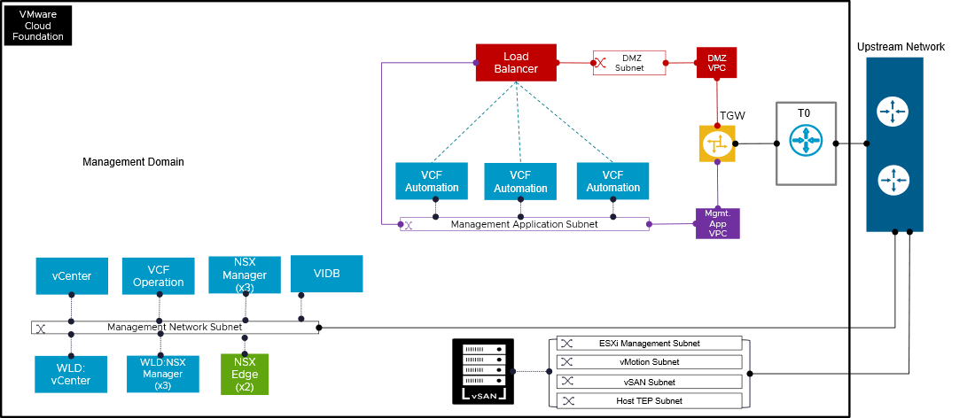
This deployment pattern helps to minimize the attack surface, contain potential security breaches, and provides the necessary controls for meeting various security and compliance standards for VCF Automation.
The DMZ VPC accommodates external facing services (like load balancers) and serve as a security barrier between the internet and the internal application network. To provide an additional layer of network isolation, this deployment pattern also uses a second VPC for the VCF Automation instances. The Transit Gateway routes traffic between the two VPCs and to the upstream network, enabling safe channels of communication.
The Tier-0 Gateway provides north and south routing as well as stateful firewall features. This offers a reliable and secure design for hosting VCF Automation that is accessible over the internet. Provider Admin can apply East - West firewall on the Mgmt App VPC to protect access to VCF Automation appliances and limit lateral movement.
Traffic Flow (Simplified for External Access):
- Web traffic enters the upstream network
- then It is sent to the load balancer in the DMZ Subnet
- Traffic is distributed among the VCF Automation instances in the Managment Application subnet by the load balancer.. .
- The TGW controls communication between the DMZ VPC and the Mgmt App VPC, and security rules are implemented both at the T0 and at this TGW level.
- The VCF Automation instances process the requests and send responses back through the same path.
Benefits | Drawbacks
- Easier to manage and update one set of VCF Automation appliances. Reduces operational overhead.  - Limits lateral movement and isolates external-facing services from core management and workloads.  - Micro-segmentation approach securely exposes services through DMZ VPC, Load Balancer, and T0 Gateway for strong protection  - Distributes traffic efficiently across multiple automation appliance instances for scale and availability. | - Needs robust security (firewalls, WAF, and API security in place).  - Load balancer misconfigurations could cause downtime or abnormal traffic routing.  - Adds network complexity; managing routing, firewall rules, and subnet allocations needs careful planning for each orgnizations or tenants.

Tenancy Deployment Models in VCF
This section describes how different tenancy models relate to the VCF fleet and VCF domain concepts, which impacts how tenants are provisioned and managed within a private cloud environment. Businesses can select a deployment model (or models) based on operational flexibility, compliance needs, and scalability requirements.
- Tenancy Deployment Model 1: Consolidated Management and Organization Workloads in a VCF Instance
- Tenancy Deployment Model 2: Shared Workload Domain for Multiple Organizations in a VCF Instance
- Tenancy Deployment Model 3: Centralized Management with Dedicated Workload Domains per Organization in a VCF Instance
- Tenancy Deployment Model 4: Centralized VCF Automation Managing Dedicated VCF Instances per Organization
- Tenancy Deployment Model 5: Dedicated VCF Fleet with Independent VCF Automation Supporting Single or Multiple Domains per Tenant

Tenancy Deployment Model 1: Consolidated Management and Organization Workloads in a VCF Instance
This tenancy deployment model consists of one VCF workload domain that hosts the management components and organization workloads.
Management components and workloads can share one vSphere cluster, or can be deployed on different vSphere clusters.
When adopting this model, carefully evaluate the potential implications, including resource contention, performance impact, security risks, and reduced availability that may arise from hosting organization workloads within the same cluster as management components.
Figure 3-6. Management and Organization Workload sharing one vSphere cluster within a vCenter
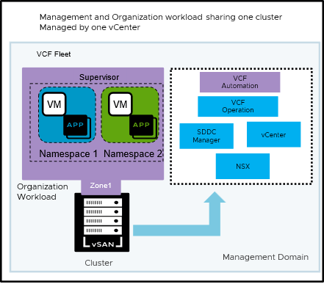
Figure 3-7. Management and organization workload on different vSphere clusters within in a vCenter
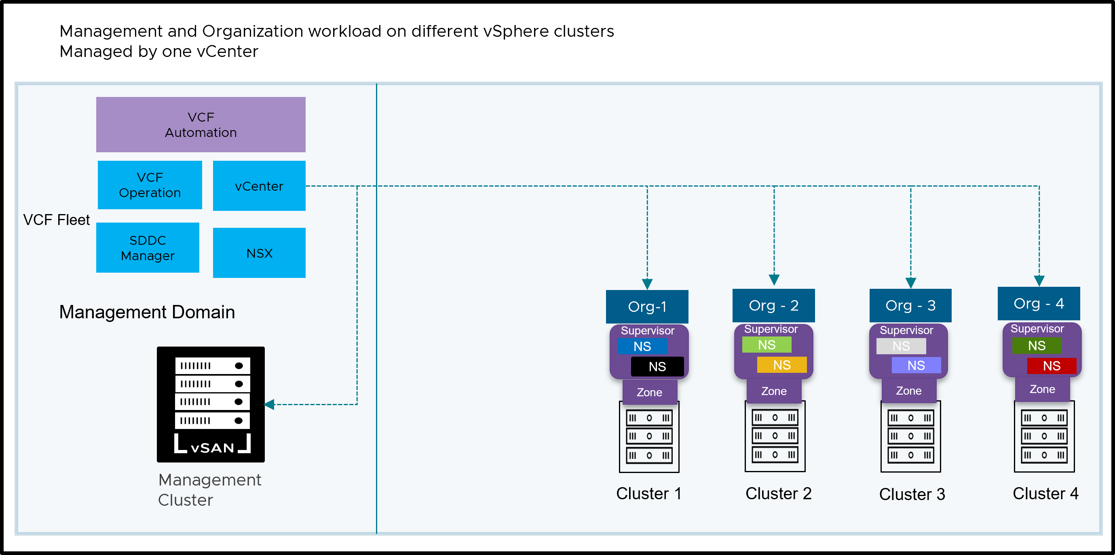
Benefits | Best Fit Scenarios
- Consolidating workloads can streamline the initial setup of a VCF Instance. There are fewer physical hosts and clusters to configure, which speeds up the deployment process.  - Using a single cluster lowers the overall hardware requirements. This can lead to cost savings in terms of server hardware, networking equipment, and data center space. | - For organizations with smaller environments and limited resource requirements, consolidating workloads can provide a cost-effective and manageable solution.

Tenancy Deployment Model 2: Shared Workload Domain for Multiple Organizations in a VCF Instance
This model offers a multi-tenant VMware Cloud Foundation platform where multiple organizations share a single workload domain. Isolation is achieved through vSphere Namespaces and network segmentation.
Figure 3-8. Shared Workload Domain for multiple organizations in a VCF Instance
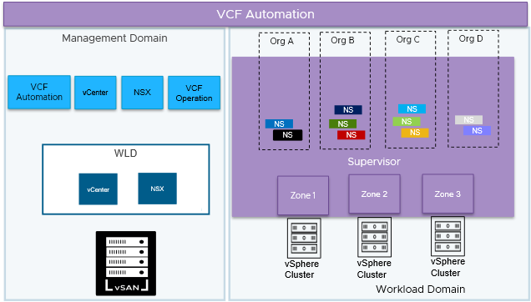
Benefits | Best fit scenarios
- Resource Sharing:  Tenants share the underlying infrastructure (workload domain, vCenter, NSX), leading to cost savings and efficient resource utilization.  - Simplified Management and Operational Consistency:  While providing tenant isolation, the centralized management of the VCF Management Domain simplifies overall infrastructure operations, including patching, upgrades, monitoring, and capacity planning. Consistent policies can be applied across all tenants.  - Scalability and Flexibility:  The model is highly scalable. As the number of tenants or their resource demands grow, the underlying workload domain can be scaled up by adding more hosts. Resource allocations within Namespaces can also be adjusted dynamically. If requirement comes, service provider can add more workload domains for multiple other organizations to share or can dedicate a workload domain per tenant like explained in Model 2.  - vSphere Namespace Isolation:  vSphere Namespaces provide logical resource isolation for tenants' workloads, preventing interference.  - Network Segmentation:  Network policies and security groups can be used to further segment tenant traffic and enhance security. | - Cloud Service Providers (CSPs) Offering Multi-Tenant Cloud Services:  This model allows the CSP to host multiple customers within a single VCF instance, maximizing resource utilization across their infrastructure. The Supervisor Cluster ensures strong isolation between each customer's workloads and data. Each customer gets their own vSphere Namespace, providing them with a secure and logically separated environment for deploying VMs and containers. Network segmentation (via NSX) further guarantees that customer traffic remains isolated.  - Large Enterprises with Multiple Business Units or Departments:  A large corporation has several independent business units (e.g., Finance, Marketing, R&D) that require their own isolated IT environments but can share underlying infrastructure.  - Organizations Offering Internal PaaS or Developer Platforms:  An organization wants to provide a self-service platform for its internal development teams to deploy and manage their applications (including containerized microservices) in an isolated and governed manner.  - Educational Institutions or Research Organizations with Multiple Projects or Teams:  A university hosts various research projects or has different departments with distinct IT requirements and security needs.

Tenancy Deployment Model 3: Centralized Management with Dedicated Workload Domains per Organization in a VCF Instance
This model provides a robust and secure multi-tenant environment by leveraging VCF Automation and dedicated workload domains. Each organization gets a dedicated environment, ensuring security, performance, and independent management. The central and shared management domain provides centralized control, while oranization-specific components offer flexibility and autonomy.
Figure 3-9. Centralized Management with Dedicated Workload Domains per Organization in a VCF Instance
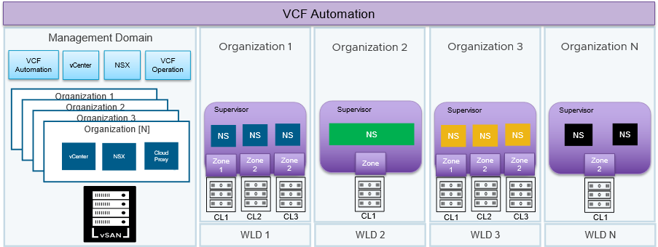
Benefits | Best fit scenarios
- Centralized Management:  Offers one control point for overseeing the entire VCF environment for service providers handling several tenants.  - Simplified Life Cycle Management:  Optimizes the updating and patching of essential VCF elements.  - Providers of multi-tenant services:  Provide safe and separate environments for various clients.  - Major corporations with separate business divisions:  Grant independence and seclusion to various departments.  - Industries with extensive regulations:  Adhere to rigorous compliance standards for data protection and confidentiality (such as healthcare, finance, public sector).  - Organizations handling sensitive information:  Provide increased security against unauthorized access and data leaks. | - Performance-Sensitive Workloads:  Applications with demanding performance needs (e.g., high-throughput databases, real-time processing) require consistent and predictable resource availability. Dedicated hardware eliminates the "noisy neighbor" effect, where the activity of other tenants can negatively impact performance.  - Specialized Hardware or Dedicated Hardware:  Some organizations may require specific hardware configurations (e.g., GPUs, specialized processors, high-performance networking) that differ from the standard infrastructure. In certain cases different organization may have a different licensing requirement depending on their hardware configurations such as different CPU cores. Dedicated workload domains allow them to use their required hardware without imposing it on other tenants.  - Data Sovereignty and Geographic Restrictions:  Some countries have data sovereignty laws that require data to be stored and processed within their borders. Dedicated workload domain can be used to create isolated environments within specific geographic locations to comply with these regulations.  - Mergers and Acquisitions:  Maintaining separation, When two organizations merge or one acquires another, they may need to maintain separate IT environments for a period (or even permanently) due to: Security policies, Compliance requirements, different IT processes, phased integration plans. Dedicated workload domains allow them to keep their infrastructure separate while still benefiting from a centralized private cloud platform.

Tenancy Deployment Model 4: Centralized VCF Automation Managing Dedicated VCF Instances per Organization
This model offers a dedicated VCF Instance (consisting of a management domain and a workload domains) for every tenant. Each tenant receives dedicated resources, in addition to common management components such as VCF Operations and VCF Automation managing both instances.
For multi-location deployments, a minimum of 10Mb/s with 100ms latency for management operations such as upgrades, patching, and cluster management is required. However, the bandwidth and latency requirements for day-to-day user operations in VCF Automation can vary significantly. These requirements depend on several factors, including:
- The number of users accessing VCF Automation.
- The geographical distribution of users and resources.
- The volume and nature of user transactions.
Figure 3-10. Centralized VCF Automation managing dedicated VCF Instances per Organization
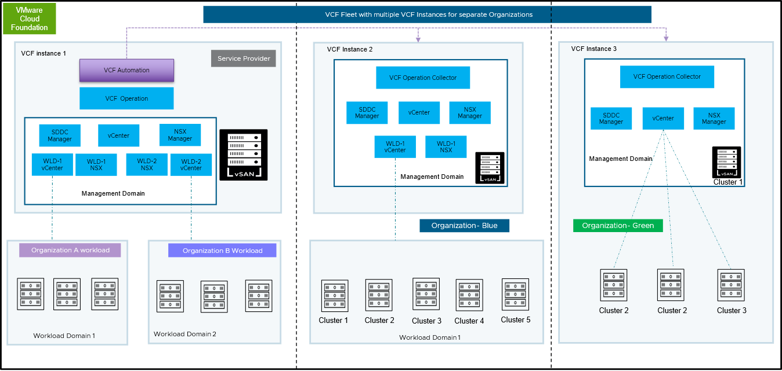
Benefits | Best fit scenarios
- This model offers a dedicated VCF Instance (comprising a Management Domain and Workload Domains) for every tenant. However, every VCF instances are consumed through one shared VCF Automation. This signifies that every tenant receives fully separate resources, encompassing compute, storage, and networking, in addition to their specific management components such as vCenter and NSX.  - Improved Security: Robust isolation stops the actions of one tenant from impacting others, reducing security threats and supporting adherence to data privacy and compliance.  - Committed Resources: Every tenant has assured access to their designated resources, guaranteeing stable performance and preventing resource conflict problems.  - Autonomous Management: Tenants possess complete authority over their environment, enabling them to oversee their resources and implement applications based on their individual requirements and regulations. Streamlined Operations: Dedicated instances reduce complexity and simplify management tasks, as each tenant's environment is self-contained. | - Large enterprises with autonomous business units: Corporations with distinct business units that have their own IT teams, budgets, and operational processes are ideal candidates for a VCF Fleet. Each business unit can have its own VCF instance tailored to its specific needs.  - Service Providers offering highly isolated environments:  Cloud Services Platforms that must provide isolated and secure environments for different enterprise customers benefit from a VCF Fleet. Each customer gets a dedicated VCF instance, ensuring maximum security and control.  - Government agencies with separate departments: Government entities with different departments that have strict security and operational autonomy requirements can deploy a VCF Fleet to ensure the necessary isolation and control for each department's workloads.  - Global organizations with regional data sovereignty needs: Multinational corporations with requirements for data to reside within specific geographic regions can deploy VCF instances in different locations, adhering to data sovereignty laws while maintaining a consistent VCF architecture.  - Organizations Undergoing Mergers and Acquisitions:  During the integration of two or more organizations, a VCF Fleet can provide a way to maintain separate environments initially and gradually consolidate or migrate workloads as needed, while ensuring isolation during the transition.

Tenancy Deployment Model 5: Dedicated VCF Fleet with Independent VCF Automation Supporting Single or Multiple Domains per Tenant
This model illustrates dedicated tenant approach where each tenant has its own isolated environment within a VCF Instance single domain or multiple domain construct. This means each tenant gets their own VCF Automation and dedicated compute and storage infrastructure such as vSphere cluster with higher level resource isolation with vSphere Automation along with vSphere Supervisor and NSX.
You can utilize the same vCenter for managing both management and compute workloads for Tenants.
Figure 3-11. Dedicated VCF Fleet with independent VCF Automation supporting single or multiple domains per tenant
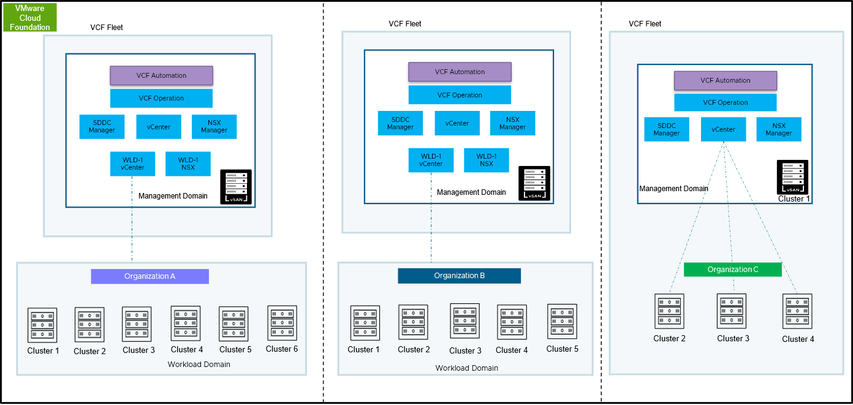
Benefits | Best fit scenarios
- Provides a dedicated VCF Fleet to each tenant. Each fleet operates with its own VCF Automation and VCF Operations instances, ensuring complete operational isolation. Within each VCF Fleet, service providers or enterprises have the flexibility to either deploy a single workload domain with multiple clusters or multiple workload domains, each containing multiple clusters. This model offers full design freedom to allocate and dedicate resources based on specific tenant or organizational needs.  - Resource Isolation and Efficiency:  This model strikes a balance between providing dedicated resources for isolation and consolidating infrastructure for efficiency. | - Organizations with strict isolation requirements but also wanting to optimize resource usage.  - Multi Geo - Complying with data sovereignty regulations  - Service Provider - Offering hosted private clouds with dedicated infrastructure.  - Supporting regulated industries with specific compliance needs.  - Providing high-value services with strict SLAs. Facilitating M&A scenarios with isolated environments.

Multi Tenancy Consumption Patterns
This section describes the multi-tenancy consumption patterns aligned with the tenancy deployment models described in the 'Tenancy Deployment Models" section. It explains the different ways multiple organizations or tenants can consume shared compute, memory, storage, and networking resources, depending on the chosen tenancy deployment model.
Before diving into design and resource isolation scenarios, let's first understand the relationship between VCF Automation, vSphere Supervisor, and NSX objects, which you will see in various patterns below.
Object Relationship | Characteristics
Tier 0 router (T0) <> Organization | A single T0 can share multiple organizations  One Organization can have multiple T0s
Organization <> Project | One Organization can have one or multiple projects.
Organization <> TGW | One Organization can have only one TGW
Project <> vSphere Namespace | One Project can have multiple vSphere Namespaces
VPC <> vSphere Namespace | One VPC can have one or more vSphere Namespaces

Multi-Tenancy Consumption Pattern 1: Resource Isolation with Single VPC for Multiple Businesses in One Supervisor Zone
This design follows a multi-tenancy consumption pattern where resources are shared among multiple tenants, but logical isolation is provided through multiple levels within the private cloud stack.
This consumption pattern prioritizes cost optimization and simplified management over strict tenant isolation.
Figure 3-12. Multi Tenancy Consumption Pattern 1: Resource Isolation with Single VPC for Multiple Businesses in One Supervisor Zone
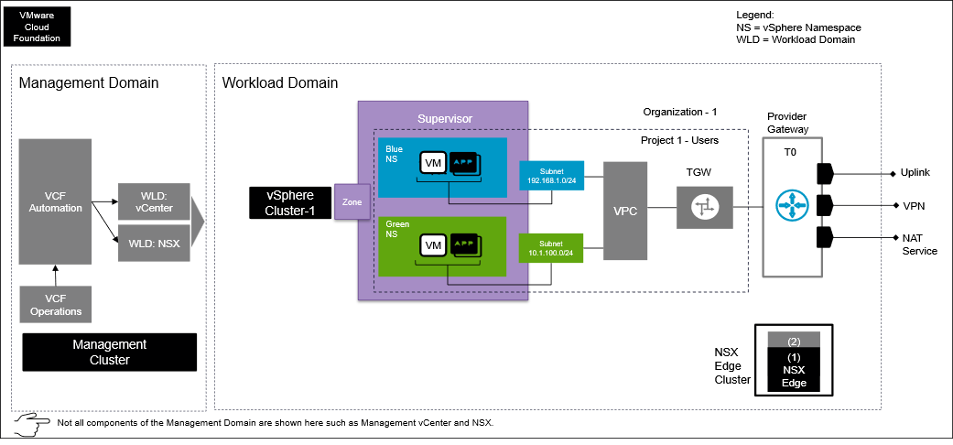
Design Attributes | Details | Diagram Representation
Organization | One | Represents as one Organization
Line of Business | Two | Describes Blue and Green as separate lines of business.
Number of vSphere Clusters | One | A compute and vSAN storage cluster used in a workload domain.
Number of vSphere Supervisors | One | vSphere Supervisor defines the scope of vSphere IaaS control plane on vCenter.
Number of vSphere Supervisor Zones | One | Zones are logical constructs within a vSphere Supervisor that represent failure domains or availability zones. Each zone is mapped to a specific vSphere cluster, ensuring that workloads deployed in a particular zone are physically located on separate hardware for high availability.
VCF Automation Project | One | Represented by "Project 1 - Users". This represents a logical project or user ownership within the environment.
Provider Gateway (T0) | One | The Tier-0 Gateway provides external connectivity. This is where NAT and VPN services are configured.
vSphere Namespaces | Two | Blue and Green line of businesses have dedicated vSphere Namespaces for workload isolation.
VPC | One | All lines of businesses / tenants share a single VPC.
Transit Gateway | One | A single Transit Gateway connects all the VPCs to the Provider Gateway.
Tenant Networks | Two | Distinct subnets are used for each vSphere Namespace, providing network segmentation.

Multi-Tenancy Consumption Pattern 2: Resource Isolation with Multiple VPCs for Multiple Lines of Business in One Supervisor Zone
This approach provides robust resource isolation for different lines of business (LOBs) within a single vSphere Supervisor Zone.
Figure 3-13. Pattern 2 : Resource Isolation with multiple VPCs for multiple line of business in one Supervisor zone
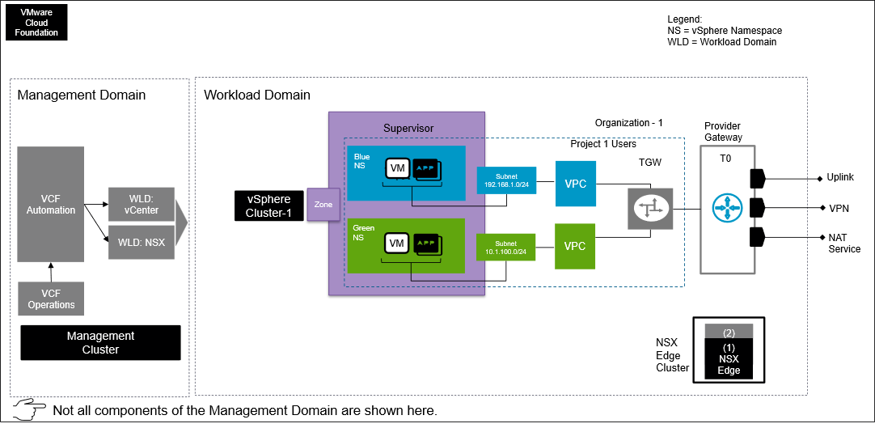
Design Attributes | Details | Diagram Representation
Organization | One | Represents as one Organization
Line of Business | Two | Describes Blue and Green as separate LOB
Number of vSphere Clusters | One | A compute and vSAN storage cluster used in a workload domain construct
Number of vSphere Supervisors | One | vSphere Supervisor defines the scope of vSphere IaaS control plane on vCenter.
Number of vSphere Supervisor Zones | One | Zones are logical constructs within a vSphere Supervisor that represent failure domains or availability zones. Each zone is mapped to a specific vSphere cluster, ensuring that workloads deployed in a particular zone are physically located on separate hardware for high availability.
VCF Automation Projects | One | Represented by "Project 1 - Users". This represents a logical project or user ownership within the environment.
Provider Gateways (T0) | One | The T0 gateway provides external connectivity. This is where NAT and VPN services are configured.
vSphere Namespaces | Two | Blue and Green LOB has dedicated vSphere Namespace for workload isolation.
VPCs | Two | Each LOB/ tenant has their own dedicated VPC for network isolation.
TGWs (Transit Gateway) | One | A single TGW connects all the VPCs to the Provider Gateway.
Tenant Networks | Two | Distinct subnets are used for each vSphere Namespace, providing network segmentation.

Multi-Tenancy Consumption Pattern 3: Resource Isolation with single VPC for multiple line of business in three Supervisor zone
This architecture provides resource isolation for multiple lines of business (LOBs) by consolidating them within a single Virtual Private Cloud (VPC) that spans three vSphere Supervisor Zones.
Figure 3-14. Pattern 3 : Resource Isolation with single VPC for multiple line of business in three Supervisor zone
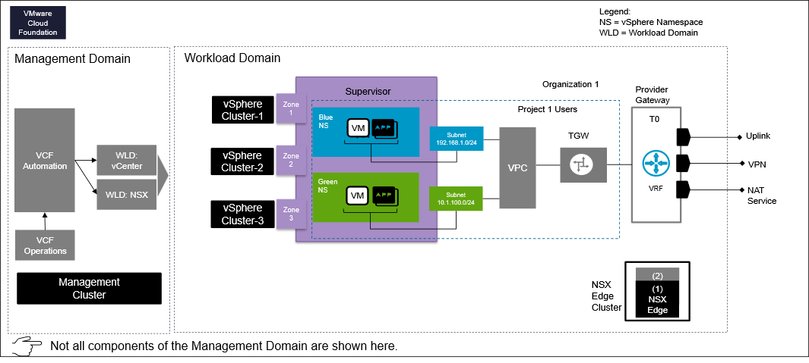
Design Attributes | Details | Diagram Representation
Organization | One | Represents as one Organization
Line of Business | Two | Describes Blue and Green as separate LOB
Number of vSphere Clusters | Three | Three compute and vSAN storage cluster used in a workload domain construct
Number of vSphere Supervisors | One | vSphere Supervisor defines the scope of vSphere IaaS control plane on vCenter.
Number of vSphere Supervisor Zones | Three | Zones are logical constructs within a vSphere Supervisor that represent failure domains or availability zones. Each zone is mapped to a specific vSphere cluster, ensuring that workloads deployed in a particular zone are physically located on separate hardware for high availability.
VCF Automation Projects | One | Represented by "Project 1 - User". This represents a logical project or user ownership within the environment.
Provider Gateways (T0) | One | The T0 gateway provides external connectivity. This is where NAT and VPN services are configured.
vSphere Namespaces | Two | Blue and Green LOB has dedicated vSphere Namespace for workload isolation.
VPCs | One | All LOB/ tenant sharing a single VPC
TGWs (Transit Gateway) | One | A single TGW connects all the VPCs to the Provider Gateway.
Organization Networks | Two | Distinct subnets are used for each vSphere Namespace, providing network segmentation.

Multi-Tenancy Consumption Pattern 4: Resource Isolation for multiple organization with dedicated VRFs
This design achieves strong resource isolation for multiple organizations by providing each with a dedicated Virtual Routing and Forwarding (VRF) instance, ensuring completely separate network routing and forwarding domains.
Figure 3-15. Pattern 4: Resource Isolation for multiple organization with dedicated VRFs
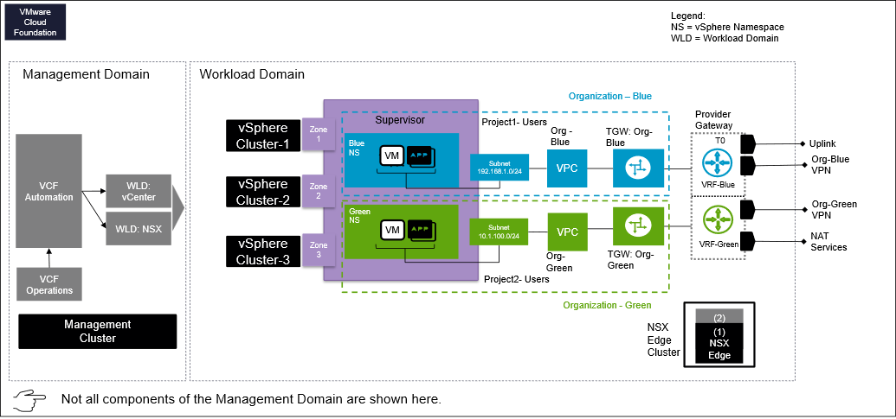
Design Attributes | Details | Diagram Representation
Management Domain | One | Centralized Management: Includes VCF Automation, workload domain vCenter, NSX, and VCF Operations. Consist of a vSphere Cluster -the underlying hardware for the management domain.
Workload Domain | One | A workload domain with three compute vSphere clusters for tenant workloads.
NSX Local Manager | One | Dedicated one NSX Local Manager per region
Organization | Two | Represents two separate Organizations. Such as Blue and Green
Number of vSphere Cluster | Three | Three compute and vSAN storage cluster used in a workload domain construct. Shared by both the organizations.
Number of vSphere Supervisor | Three | vSphere Supervisor defines the scope of vSphere IaaS control plane on vCenter.
Number of vSphere Supervisor Zone | Three | Zones are logical constructs within a vSphere Supervisor that represent failure domains or availability zones. Each zone is mapped to a specific vSphere cluster, ensuring that workloads deployed in a particular zone are physically located on separate hardware for high availability.
VCF Automation Project | Two | Represented by "Project 1 - Users" and "Project 2- Users". This represents a logical project or user ownership within the environment.
Provider Gateway (T0) | One | A single T0 gateway provides external connectivity, including Uplink, VPN, VRF (Virtual Routing and Forwarding), and NAT services.
VRF | Two | Each tenant has a dedicated VRF instance ("VRF: Tenant Blue" and "VRF: Tenant Green") for enhanced network segmentation and isolation. VRF resides in the T0 construct.
vSphere Namespace | Two | Blue and Green tenant has dedicated vSphere Namespace for workload isolation.
VPC | One | All LOB/ tenant sharing one VPC
TGW (Transit Gateway) | Two | Each tenant has a dedicated TGW, "TGW: Tenant Blue" and "TGW: Tenant Green", for connecting their respective VPCs.
Organization Networks | Two | Distinct subnets are used for each vSphere Namespace, providing network segmentation.

Multi-Tenancy Consumption Pattern 5: Multi-Region, Multi-Tenant Resource Isolation with Dedicated and Shared Gateways
This design provides multi-tenant resource isolation across multiple regions by combining dedicated gateways for strict tenant separation with shared gateways for efficient common services.
Figure 3-16. Pattern 5: Multi-Region, Multi-Tenant Resource Isolation with Dedicated and Shared Gateways
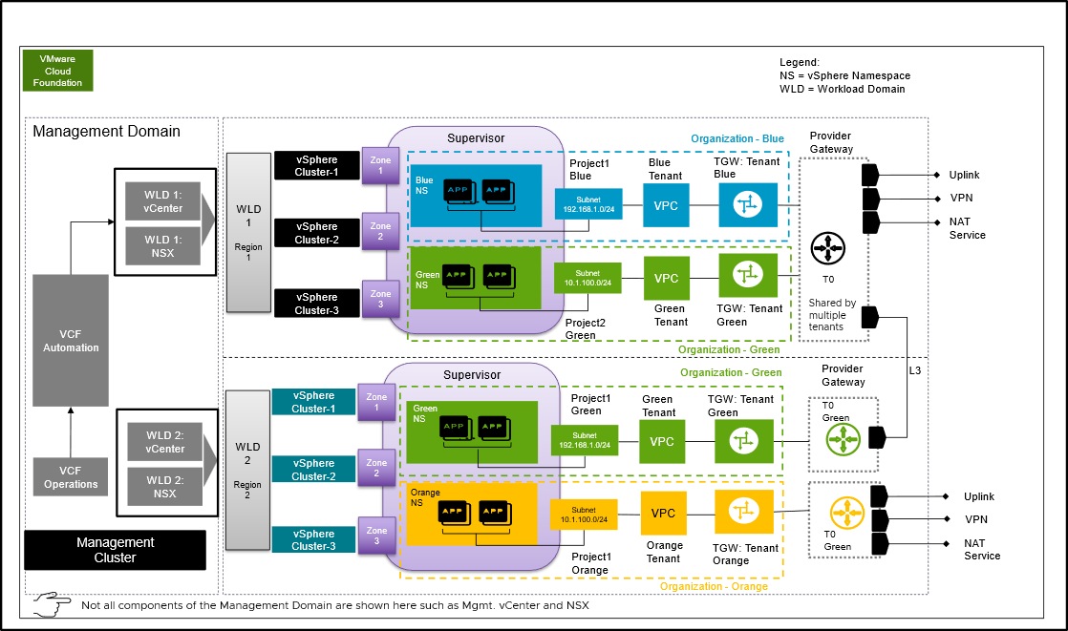
Important In the context of VCF Automation Region
- A region consists of one or more vSphere Supervisor.
- A region is a collection of compute, memory, storage, and networking resources that can span across vCenter instances.
Design Attributes | Details | Diagram Representation
Management Domain | One | Centralized Management: Includes VCF Automation, workload domain vCenter, NSX, and VCF Operations. Consist of a vSphere Cluster -the underlying hardware for the management domain.
Workload Domains | Two | A workload domain with three compute vSphere clusters for tenant workloads.
NSX Local Managers | Two | Each workload domain has one NSX local manager
Organizations | Three | Represents three separate Organizations. Such as Blue, Green and Orange
Number of vSphere Clusters | Six | Six compute and vSAN storage cluster used in two workload domain construct.
Number of vSphere Supervisors | Six | vSphere Supervisor defines the scope of vSphere IaaS control plane on vCenter.
Number of vSphere Supervisor Zones | Six | Zones are logical constructs within a vSphere Supervisor that represent failure domains or availability zones. Each zone is mapped to a specific vSphere cluster, ensuring that workloads deployed in a particular zone are physically located on separate hardware for high availability.
VCF Automation Projects | Three | Represented by "Project 1 - User" and "Project 2- User". This represents a logical project or user ownership within the environment.
Provider Gateways (T0) | One in each region | A single T0 gateway provides external connectivity, including Uplink, VPN, VRF (Virtual Routing and Forwarding), and NAT services.
VRFs | Two | Tenant "Green" and "Orange" has a dedicated VRF instance in a T0. Both tenant sharing a T0 but still they have network isolation.
vSphere Namespaces | Two | Blue and Green tenant has dedicated vSphere Namespace for workload isolation.
VPCs | One | Each LOB/ tenant sharing a single VPC
TGWs (Transit Gateway) | Two | Each tenant has a dedicated TGW, "TGW: Tenant Blue" and "TGW: Tenant Green", for connecting their respective VPCs.
Tenant Networks | Four | Distinct subnets are used for each vSphere Namespace, providing network segmentation.

Multi-Tenancy Consumption Pattern 6: Multi-Organization resource isolation with shared NSX across workload domains
This design provides multi-organization resource isolation across distinct workload domains by leveraging a shared NSX platform to centrally manage and logically segment network and security services for each tenant.
Figure 3-17. Pattern 6: Multi-Organization resource isolation with shared NSX across workload domains
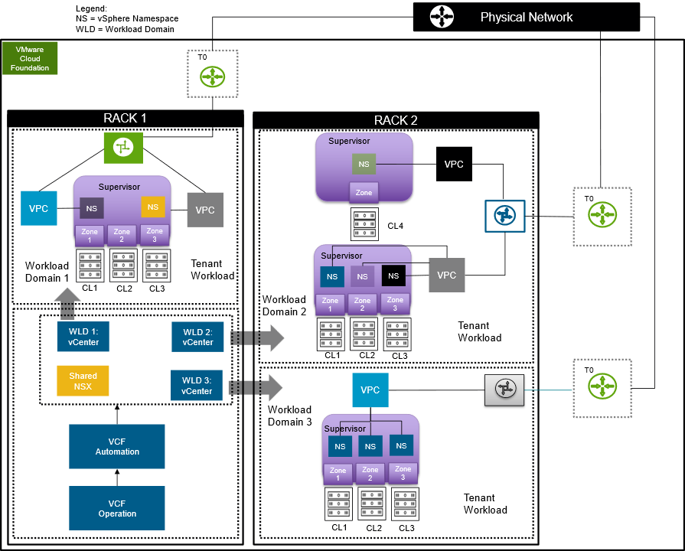
Please refer workload networking section for mode detailed information around workload networking. Workload Networking Detailed Designs
Design Attributes | Details | Diagram Representation
Management Domain | One | Centralized Management: Includes VCF Automation, workload domain vCenter, NSX, and VCF Operations. Consist of a vSphere Cluster -the underlying hardware for the management domain.
Workload Domains | Three | A workload domains with three compute vSphere clusters for tenant workloads.
Shared NSX Local Managers | One | Workload domains share a NSX local manager deployment.
Organizations | Three | Each workload domain represents as one organization workload.
Number of vSphere Clusters | Ten | Ten compute and vSAN storage clusters used in a three workload domain construct.
Number of vSphere Supervisors | Ten | vSphere Supervisor defines the scope of vSphere IaaS control plane on vCenter.  In this design Workload Domains 1 and 3 each have a 3 zone vSphere Supervisor. Workload Domain has a 3 zone vSphere Supervisor as well as a sepeate 1 zone vSphere Supervisor for a total of 10 zones.
Number of vSphere Supervisor Zones | Ten | Zones are logical constructs within a vSphere Supervisor that represent failure domains or availability zones. Each zone is mapped to a specific vSphere cluster, ensuring that workloads deployed in a particular zone are physically located on separate hardware for high availability.  In this design Workload Domains 1 and 3 each have a 3 zone vSphere Supervisor. Workload Domain has a 3 zone vSphere Supervisor as well as a sepeate 1 zone vSphere Supervisor for a total of 10 zones.
VCF Automation Projects | Three | Represented by "Project 1 - User" and "Project 2- User". This represents a logical project or user ownership within the environment.
Provider Gateways (T0) | One in each region | A single T0 gateway provides external connectivity, including Uplink, VPN, VRF (Virtual Routing and Forwarding), and NAT services.
vSphere Namespaces | Nine | Various vSphere Namespaces across the vSphere Supervisors.
VPCs | Five | Various VPCs assigned across the vSphere Namespaces
TGWs (Transit Gateway) | Three | Each Workload Domain has a dedicated TGW.
Tenant Networks | Multiple | Distinct subnets are used for each vSphere Namespace, providing network segmentation.

VCF Automation Identity and Access Management Design
As part of the VCF Automation, you configure authentication to grant user access and provide granular control of resources.
VCF Automation contains two persona levels. The provider persona manages the core infrastructure and the tenant / line-of-business (LOB) persona manages the individual tenants within that infrastructure. Each of these personas have different authentication options.
VCF Automation Personas | Capabilities
Provider | - Installs and manages core VCF Automation infrastructure  - Provider / Enterprise level administrative functions  - Manages shared content libraries published to organizations  - Creates organizations, assigns resource quotas, regional networking and first tenant user
Tenant / LOB | - Manages organizations  - Creates and manages projects  - Creates and manages vSphere Namespaces  - Configures Content Hub  - Creates blueprints  - Provides organization level user management

Provider Persona Attributes
The provider level supports three primary identity providers along with the default local admin account.
Attribute | Details
VCF SSO | - Embedded or appliance VCF Identity Broker  - Provides consistent SSO across the VMware Cloud Foundation platform  - VCF Identity Broker supports multiple different simultaneous LDAP and / or Active Directory connections
LDAP | - Allows for the configuration of a single Active Directory or OpenLDAP connection
SAML | - Assumes upstream SAML identity provider
Default Local Admin Account | - Local admin account created during initial install of VCF Automation  - Full admin rights  - Only one local admin account allowed
Table 3-11. VCF Automation Provider Authentication Requirements
Design Requirement ID | Design Requirement | Justification | Implications
VCF-AUTO-REQD-PROV-001 | Configure an identity provider for the Provider. | - Allows provider to leverage an enterprise directory.  - Enables named access control to Infrastructure level constructs.  - Required to provision administrative access to the Provider Administrator Portal for any account other than the default local admin account. | If not configured, the only access to the Provider Administrator Portal will be through the default local admin account created during installation.
VCF-AUTO-REQD-PROV-002 | Leverage the VCF Identity Broker identity provider. | - Provides Single Sign-On with the rest of the components.  - Leverages the authentication direction for VMware allowing support for future enhancements. | None.

Tenant Persona Attributes
The tenant level accepts three primary identity providers along with the default local admin account.
Attribute | Details
OpenID Connect (OIDC) | - Allows for configuration of a OIDC identity provider
LDAP | - Allows for the configuration of a single Active Directory or OpenLDAP connection
SAML | - Assumes upstream SAML identity provider
First user | - Created during initial deployment of a tenant  - Organizational administrator role  - Is a local account
Table 3-12. VCF Automation Tenant Authentication Requirements
Design Requirement ID | Design Requirement | Justification | Implications
VCF-AUTO-REQD-TEN-001 | Configure an identity provider for Tenants. | - Allows tenant to leverage enterprise directory.  - Enables named access control to tenant level constructs.  - Required to provision administrative or user access to the Organization portal for any account other than the first user account established during Organization creation. | If not configured, the only access to the Organization Portal will be through the first user account established during Organization creation.

VCF Automation Enterprise Authentication Design
The VCF Automation Enterprise Authentication Model configures both the provider and tenant to authenticate to the same identity provider.
Figure 3-18. VCF Automation Enterprise Authentication Model
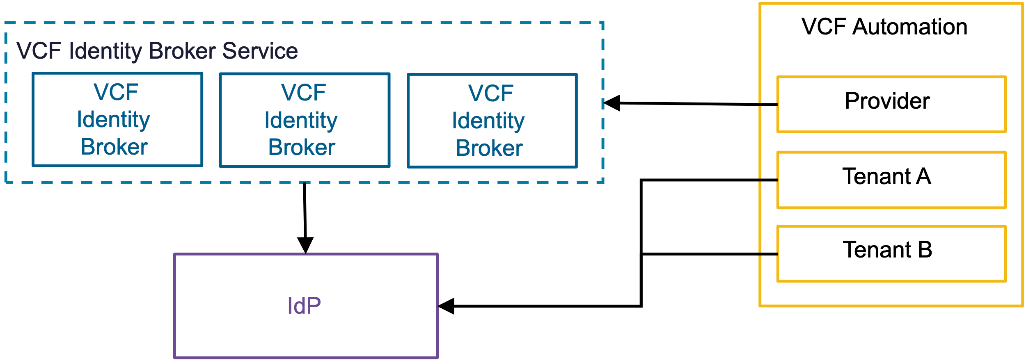

VCF Automation Enterprise Authentication Design Attributes
A VCF Automation enterprise authentication model has the following attributes.
Attribute | Detail
Provider | - The provider organization connects to the VCF Identity Broker service.  - VCF Identity Broker sources the users and groups from the identity provider.  - The provider uses the same identity provider as the tenant.
Tenant | - The tenant organization connects directly to the identity provider through either OIDC or SAML.  - The tenant uses the same identity provider as the provider.
Single Sign-On scope | - The provider log-ins have Single Sign-On with the rest of VCF components.  - The tenant log-ins do not have Single Sign-On with the rest of VCF components.

VCF Automation Enterprise Authentication Model Options
A VCF Automation Enterprise Authentication Model can leverage options from the design areas listed below, depending on objectives.
Design Area | Options
VCF Identity Broker models | - Embedded VCF Identity Broker Model  - Appliance VCF Identity Broker Model
Table 3-13. VCF Automation Enterprise Authentication Design Requirements
Design Requirement ID | Design Requirement | Justification | Implications
VCF-AUTO-REQD-IDP-001 | The provider uses the same IdP as the tenant. | - Allows consistent authentication across provider and tenant | None

VCF Automation Service Provider Authentication Design
The VCF Automation Service Provider Authentication Model configures the provider and tenant to authenticate to different identity providers.
Figure 3-19. VCF Automation Service Provider Authentication Model
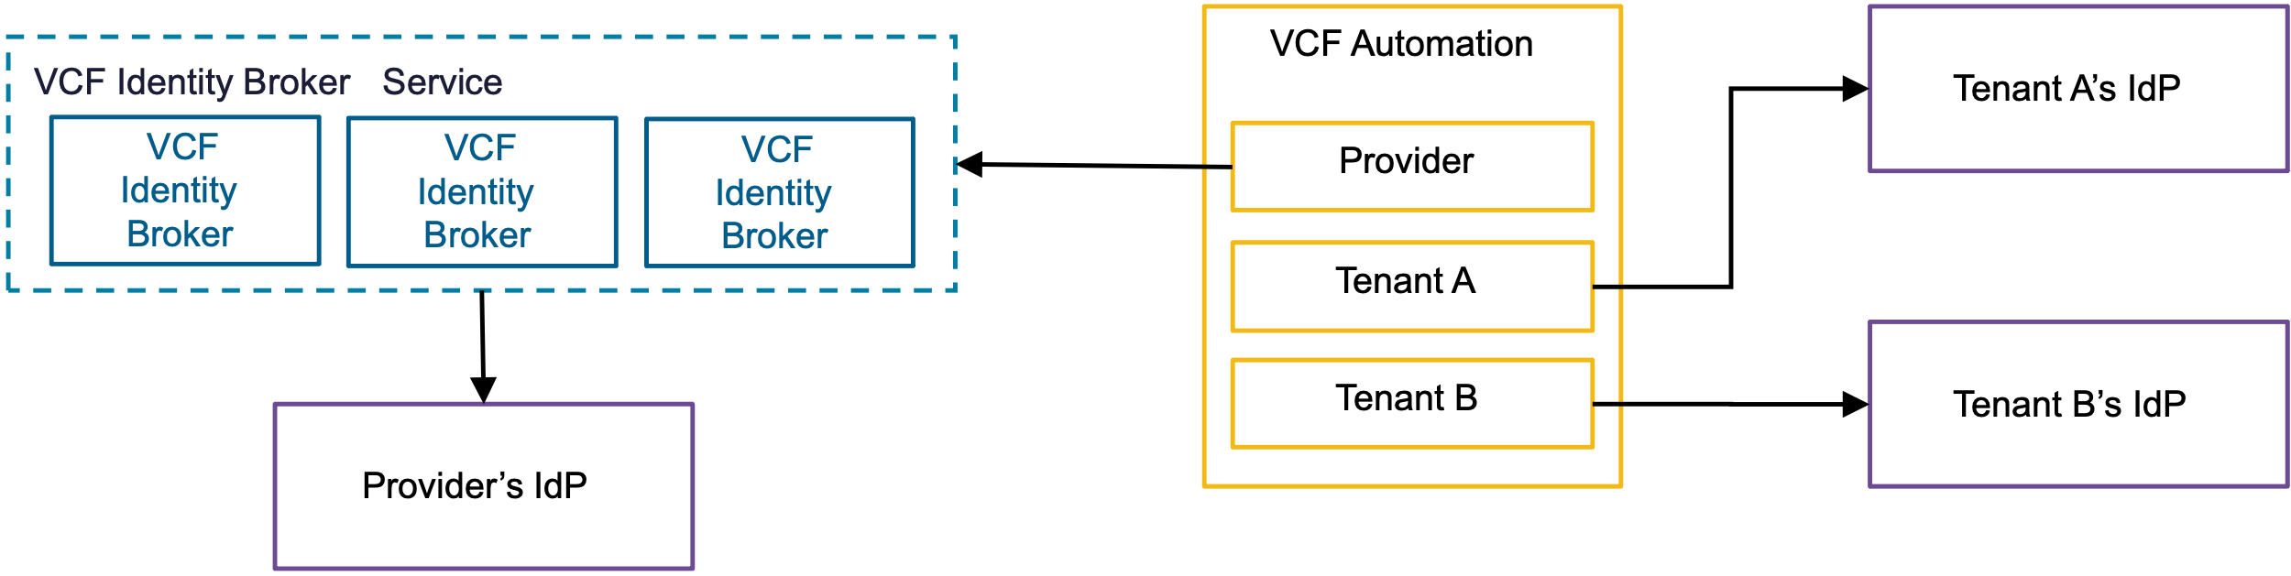

VCF Automation Service Provider Authentication Design Attributes
Attribute | Detail
Provider | - The provider organization connects to the VCF Identity Broker service.  - The VCF Identity Broker sources the users and group from the identity provider.  - The provider uses a different identity provider than the tenant.
Tenant | - The tenant organization connects directly to the identity provider through OIDC or SAML.  - The tenant uses a different identity provider than the provider.
Single Sign-On scope | - The provider log-ins have Single Sign-On with the rest of VCF components.  - The tenant log-ins do not have Single Sign-On with the rest of VCF components.

VCF Automation Service Provider Authentication Model Options
A VCF Automation Service Provider Authentication Modelcan leverage options from the design areas listed below, depending on objectives.
Design Area | Options
VCF Identity Broker models | - Embedded VCF Identity Broker Model  - Appliance VCF Identity Broker Model

VCF Automation Service Provider Authentication Design Requirements
Table 3-14. VCF Automation Service Provider Authentication Design Requirements
Design Requirement ID | Design Requirement | Justification | Implications
VCF-AUTO-REQD-IDP-002 | The provider uses a different IdP than the tenant. | - Supports separate authentication mechanisms for provider and tenant. | None

VCF Automation Role Base Access Control
Managing multi-tenant cloud environments demands a clearly established role-based access control (RBAC) strategy to guarantee restricted access, tenant separation, and secure operations.
Table 3-15. Best Practices for Efficient Role-Based Access Control
Best Practice | Recommendation
Principle of Least Privilege | Ensure users are granted only the permissions absolutely necessary for their specific roles, minimizing security risks.
Regular Review & Updates | Continuously review and update RBAC assignments to ensure they align with any changes in user roles and responsibilities.
Logging & Auditing | Implement logging and auditing to track user access and actions, providing transparency and accountability.
User Education | Provide ongoing training on the importance of role-based access and secure credential handling to prevent security breaches.
Integrate Third-Party Solutions for RBAC Optimization | Consider using external tools for more streamlined RBAC management, detailed reporting, and enhanced control.
VCF provides a platform to create and manage secure and multi-tenant environments. Implementing role-based access control for the management components offers the following benefits.
Table 3-16. Role-Based Access Control Design for Service Providers
Attribute | Detail
Separate Administrator roles | Establish distinct roles for service provider admins, such as managing infrastructure, provisioning resources, and troubleshooting tenant issues.
Provider Admin levels | To control access to sensitive areas, differentiate roles for basic resource management, advanced configuration, and network administration .
Multi-Factor Authentication for all privileged accounts | Implement Multi-Factor Authentication (MFA) for all privileged accounts, including both tenant and service provider administrators.
Table 3-17. RBAC Design for Tenants
Attribute | Detail
Predefined Tenant roles | Create predefined roles such as tenant user, tenant operator, and tenant administrator with permissions based on specific needs.
Custom roles for granularity | Implement custom roles for specific workflows, such as a deployment engineer, with permissions to deploy templates without managing infrastructure.
Least privilege | Apply the principle of least privilege to grant only the minimum permissions needed for each role to perform their tasks effectively.

VCF Automation Default Provider Level Global Roles
These are the default system level roles found in the Provider Admin Portal.
- They are automatically published to all Organizations
- Custom roles can be created at Provider Admin level and then published to one, many, or all Organizations as necessary
Table 3-18. VCF Automation Default Provider Level Global Roles
Role | Description | Published to other Organizations
Defer to Identity Provider | Rights will be determined based on information received from IdP | Yes, Default - All Organizations
Organization Administrator | Owns an Organization and can add users/groups to the organization | Yes, Default - All Organizations
Organization Auditor | Audit an Organization | Yes, Default - All Organizations
Organization User | Rights given to an organization user | Yes, Default - All Organizations
Custom role | Use "new" role button in the Access Control screen to create a custom role as necessary | Can be granularly published to one, many or all Organizations as necessary

VCF Automation Default Organization Level Roles
These are the default Organization level roles.
- Organization level roles govern who can log into the Organizational level portal and with what rights
- Organizations can also inherit custom roles created and subsequently published from the Provider Admin level
- Organizations Administrators can also create custom roles at the Organization level
Table 3-19. VCF Automation Default Organization Level Roles
Role | Description | Considerations
Defer to Identity Provider | Rights will be determined based on information received from IdP | - Inherited from Provider Level Global Roles  - Cannot be edited at Organization level
Organization Administrator | Owns an Organization and can add users/groups to the organization | - Inherited from Provider Level Global Roles  - Cannot be edited at Organization level
Organization Auditor | Audit an Organization | - Inherited from Provider Level Global Roles  - Cannot be edited at Organization level
Organization User | Rights given to an organization user | - Inherited from Provider Level Global Roles  - Cannot be edited at Organization level
Custom role | Use "new" role button in the Access Control screen to create a custom role as necessary | - Created specifically for the Organization  - Cannot be published to other Organizations

VCF Automation Default Organization Project Level Roles
Even if a user has access to the Organization portal, they still need to be assigned specific rights at the Project level to access and manage resources.
- Once a Project is created, the administrator must assign users to the a specific role
- The role assigned to the user applies to all Namespaces created within the Project
Table 3-20. VCF Automation Default Organization Project Level Roles
Role | Description
Project Administrator | Can manage members and catalog content
Project Advanced User | Can request catalog items and use IaaS services
Project User | Can request catalog items
Project Auditor | Can view all project content but cannot request

VCF Automation Load Balancing Design
VCF Automation runs within a Kubernetes-based container environment. The native load balancer is the default automatically configured load balancer for both the simple and highly available deployment models.
Important Note: This section does not cover load balancing for subsidiary functions, such as:
- Workload load balancing
- Load balancing of single sign-on solutions such as VMware Identity Broker
- vSphere Supervisors

If an external load balancer is used, it is an optional post-deployment manual configuration. The external load balancer points to the native load balancer as the ingress point for VCF Automation.
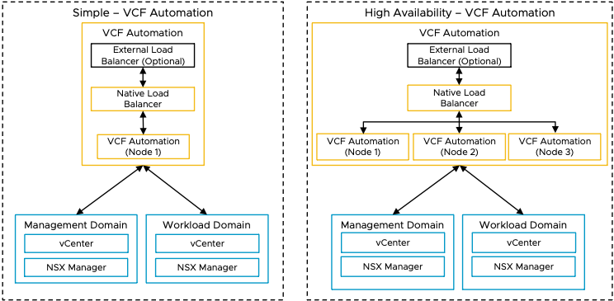
Default Load Balancer | Additional Load Balancer Options
Native Load Balancer | Can add external, 3rd-party load balancer in front of native load balancer  External, 3rd-party load balancers include VMware Avi Load Balancer

VCF Operations Orchestrator Design
VCF Operations orchestrator is a workflow automation solution designed to simplify the automation of complex IT tasks.
VCF Operations orchestrator helps improve service delivery efficiency, operational management, and IT agility. VCF Operations orchestrator is built with an open and flexible architecture that system administrators and IT operations staff can use to streamline tasks and integrate functions with third-party software through workflows.
VCF Operations Orchestrator Deployent Options
Orchestrator Deployment Options | Remarks | Recommended Scenario
Embedded | By default it will be installed as part of VCF Automation deployment | - Used by the Provider Consumption Organization  - Used by Provider Admin to create workflows that can be published to Organizations
External | It can be installed manually | - External VCF Operations orchestrator should be used by Organizations that want to create and publish their own workflows.  - Each Organization can have only one VCF Operations orchestrator instance.  - The Provider Admin deploys, manages and provides access to the external VCF Operations orchestrator used by Organizations
Figure 3-20. VCF Operation Orchestrator Deployment Design for Multiple Organizations
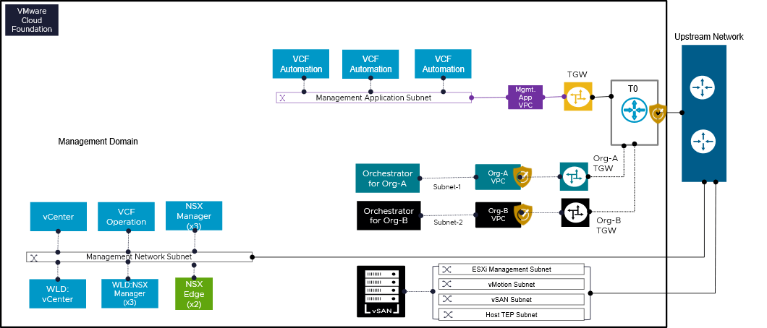
The architecture introduces separate, isolated VCF Operations orchestrator instances for every organization in a CSP environment (e.g., "Orchestrator for Org-A", "Orchestrator for Org-B"). These organizational VCF Operations orchestrator instances are each hosted in a logically distinct network segment or Virtual Private Cloud (VPC). These dedicated VCF Operations orchestrator instances ensure controlled and safe communication by establishing a secure connection to the centralized VCF management components. This architectural pattern enables any organization to take advantage of economies of scale provided by the shared underlying VCF infrastructure while managing and carrying out its unique automation workflows and operational tasks with logical separation and autonomy.
Design Attributes | Details
VCF Operations orchestrator Deployment Model | A dedicated VCF Operations orchestrator instance is deployed for each organization (e.g., "Orchestrator for Org-A," "Orchestrator for Org-B").
Network Isolation and Segmentation | - Each organization's VCF Operations orchestrator instance resides within its own distinct Virtual Private Cloud (VPC), providing inherent network isolation (e.g., "Org-A VPC," "Org-B VPC").  - Specific subnets are allocated within each organizational VPC for the VCF Operations orchestrator instances (e.g., "Subnet-1" for Org-A, "Subnet-2" for Org-B).
Firewall and Security Enforcement | Add on services such as vDefend can be used to create east -west and north south firewall policies to further protect traffic patterns. These policies will control and secure traffic flow to and from each organization's Orchestrator and its associated workloads, ensuring proper access control and segmentation.  Provider Admin can apply DFW policies on the NSX Project level in the case of individual NSX Projects.

VCF Operations Orchestrator for the Provider Consumption Organization
The VCF Automation deployment includes the embedded VCF Operations orchestrator by default.
After the provider admin creates a workflow in the embedded VCF Operations orchestrator, the workflow can be published to the catalog, either:
- As a catalog item for sole use by the provider admin
- As as catalog item that is available to all Organizations
Any workflow built in the PCO then published to all Organizations runs on the embedded VCF Operations orchestrator, even when run by a user in a non-PCO Organization.
If an Organization wishes to create and publish their own workflows within their Organization, they cannot use the PCO's embedded VCF Operations orchestrator. The Organization must use an external, dedicated VCF Operations orchestrator instance.

Chargeback and Billing
Chargeback is a cost management solution designed to help service providers accurately track and distribute expenses within a private cloud environment. It enables both providers and tenants to gain insights into resource usage and ensures fair cost allocation based on consumption. As a plug-in for tenants, Chargeback provides a metering and billing interface that simplifies usage tracking, measurement, and invoicing for services delivered through VCF Automation and VCF Operation.
Chargeback is an essential component of cloud services, particularly for service providers using VMware Cloud Foundation. It involves assigning the costs of cloud resources and services to the users or departments that actually use them. This practice is critical for both service providers and tenants, as it creates a transparent and clear method for billing and payment.
In older versions of VCF, service providers used VMware Cloud Director (VCD) to handle things like pricing, billing, and dashboards. But in VCF 9.0, these tasks will be managed directly through VCF Automation. This change likely aims to streamline operations, reduce dependencies on external systems, and provide a more integrated experience for providers within the VCF platform.
Figure below describes a high level overview how Chargeback and Billing is integrated part of VCF Operation. VCF Operations acts as the central management hub. It's the starting point for data collection and integration.
Management Packs (MPs):
VCF Operations utilizes Management Packs (MPs) to collect data from specific components. These MPs are like plugins or modules that enable integration. Management pack shown here are i) VCF Automation MP, vCenter MP and NSX MP. It shows a one-to-one relationship between each Management Pack and its corresponding component. This suggests a direct integration between each MP and its respective data source.
Figure 3-21. Chargeback Integration with VCF Operation
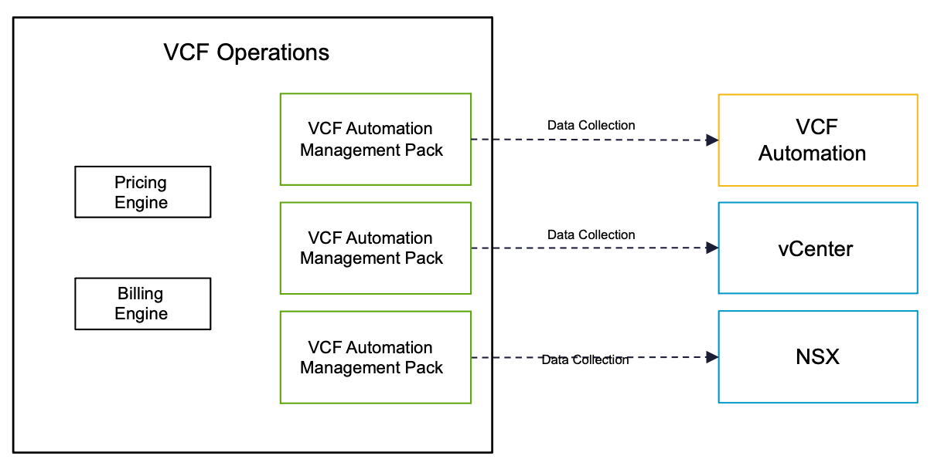
Key Use Cases:
Flexible Pricing (Rate Cards):
- Service providers need the ability to set their own prices for different resources (like storage, compute, network) based on regions or quotas. This allows them to offer tailored pricing plans to their customers.
Accurate Billing (Bills):
- Providers must be able to generate and provide detailed bills to their customers, showing usage and charges for organizations or specific resource allocations (quotas) in different regions.
Usage Monitoring (Dashboards):
- Providers need ready-to-use dashboards that give them a clear view of how their resources are being used by customers.
Customized Provider Interface (Control Panel and Launchpad):
- Providers need a customized interface (control panel and launchpad) that allows them to manage and configure their services and resources in a way that suits their specific needs.
High-level Steps to Initiate Billing
1. VCF Fleet is deployed - VCF Operations and VCF Automation are integrated by default
- Both VCF Operations and VCF Automation are deployed as part of the VCF Fleet
- VCF Automation has a one-to-one integration with VCF Operations, meaning that you can only connect one VCF Automation instance to one VCF Operations instance
- VCF Operations automatically collects data from VCF Automation as well as being able to manage functions such as billing (this can be verified in VCF Operations under Administrator > Integrations, then confirm that the VCF Automation for All Apps Organization is collecting data
2. Create and configure an All Apps Organization
- Complete initial Organization creation in the VCF Automation Provider Administrator Portal
- Complete customization of the Organization as well as deploy any VM or container resources in the VCF Automation Organization Administrator Portal
3. Create Organization Bill in VCF Operations
- In the VCF Operations UI, navigate to Capacity > Cost > Bills tab
- In the Bills tab,
  - Generate a one-time bill
  - Schedule a recurring
  - Note: The bill can be tied to either the Organization or a Region Qutoa
4. View Organization Bill in VCF Automation
- Log in to the VCF Automation Organization Administrator Portal with Organization Admin or Organization Auditor rights, then navigate to Administer > Bills to view any bills associate with the Organization
- Note: Organization Users do not have access to billing

References
The following section lists the documentation resources which were used for this document.

